**Timothy Scott Beck M.D.**

Curriculum Vitae

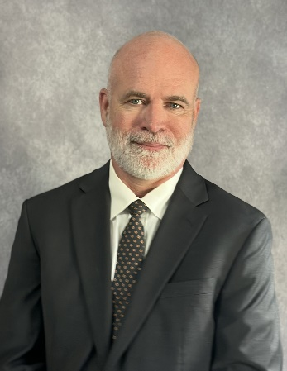

**ADDRESS/CONTACT**

Third Opinion MD, LLC Tel. 706-982-4156

P.O. Box 384

Clayton, GA 30525

[referrals@thirdopinionmd.com](mailto:referrals@thirdopinionmd.com)

**EDUCATION AND POSTGRADUATE TRAINING**

Bachelor of Science in Biology, Minor in Chemistry, Georgia Southern University 1997

Medical Doctor, Medical College of Georgia 2001

Greenville Memorial Hospital Internship, Department of Internal Medicine 2002

Greenville Memorial Hospital Residency Department of Internal Medicine 2004

**LICENSURE AND CERTIFICATIONS**

Board Certification, American Board of Internal Medicine 2004, 2014-present

Georgia Medical License 2004-present

North Carolina Medical License 2011-present

South Carolina Medical License 2011-present

FL Department of Health Medical Doctor Expert Witness Certificate MEEW11167

**MEDICAL LEGAL EXPERIENCE**

Expert Witness/Consulting 2012-present

Trial and Deposition Experience

Greater than 180 Professional Medical Opinions Rendered

* Internal Medicine
* Plaintiff and Defense
* Standard of Care
* Wrongful Death
* Personal Injury
* Elder Abuse
* Nursing Homes
* Infections
* Pressure Wounds
* Lift Failure
* Assault
* Medication Errors
* Long-term Care
* Failure to Diagnose

**MEDICAL PROFESSIONAL EXPERIENCE**

Life Point Medical, LLC, Internist, full time practicing physician 2016-present

Mountain View Nursing Home, Internist 2005-2009, 2017-present

Third Opinion MD, Internist 2011-present

Personal Lab Services, Medical Director 2013-2017

Toccoa Clinic Medical Associates, Internist 2012-2016

Network Geriatric Services, Internist 2011-2012

Greenville Memorial Hospital, Hospitalist 2010-2011

Beck’s Healthcare, LLC, Physician/Owner 2004-2009

**DISCIPLINARY ACTIONS, SANCTIONS, LAWSUITS**

None

**PROFESSIONAL AND HONOR SOCIETY MEMBERSHIPS**

Golden Key Honor Society 1997-present

Beta Beta Beta Biological Honor Society

American Academy of Family Physicians

Georgia Academy of Family Physicians

National Board of Physicians and Surgeons

**HONORS AND AWARDS**

J.C. Dover Wheel Award, Clayton Rotary Club 2023

Best Doctor in Clayton, Readers Choice Awards, The Clayton Tribune 2019,2023

Leadership and Service Award

Academic Excellence Award

Foxfire Foundation Academic Scholarship

Who’s Who Among Students in American Universities and Colleges

**COMMUNITY VOLUNTEER, MILITARY AND CIVIC ACTIVITIES**

Foster Parent 2019-2023

Board Member, Place of Hope 2019-present

Board Member, Foxfire Community Board 2004-2009, 2011-2016

Board Member, Citizens Against Violence 1996-1997

Preceptor, Phase 1 Physical Diagnosis, Medical College of Georgia 2000

Clinical Mentor, Medical College of Georgia 1999-2000

President, Family Medicine Interest Group, Medical College of Georgia 1998

Beta Beta Beta Biological Honor Society, Georgia Southern University 1997

Volunteer, United Cerebral Palsy of the CSRA, 600+ hours 1994-1996

Volunteer, Big Brothers and Sisters of America 1990-1992

Blood Drive Coordinator, American Red Cross 1995-1996

Honor Guard, Bugler, Fairchild Air Force Base 1991-1992

United States Air Force, Active Duty, Enlisted 1989-1994

**PERSONAL INTERESTS**

Community Health and Prevention

Education/Children’s Welfare

Family, Banjo, Reading, Mountain Biking, Hiking

Revised 1/2/25