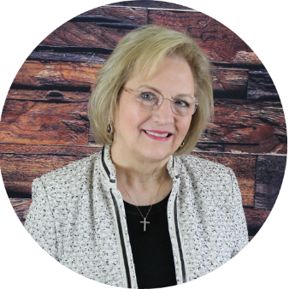
BARBARA TARIN, CCIM
RESIDENTIAL AND COMMERCIAL REAL ESTATE EXPERT
4711 Willowood Lane
Temple, Texas 76502
Office (210) 885-7400, Cell (210) 885-7400
Fax (254) 295-0257, email btarin@hot.rr.com, www.TarinRealEstate.com

Over 45 Years Expertise in All Areas of Real Estate

- Real Estate Expert Witness – Ethics, Lease Disputes, Property Management
- Commercial and Residential Brokerage and Consulting
- Property Management 19 years – Office (garden, mid rise and high rise), Retail, Industrial, Multi-family (up to 32,000 units)
- Land Acquisition, Feasibility, Financial Analysis, Development
- Marketing and Market Analysis
- Lease expert from both the Landlord and Tenant Perspective – Director of Leasing for up to 1.7 million square feet projects
- National Real Estate Instructor since 1988

Education: BBA Finance- UTSA 1997
CCIM Institute - CCIM Designation 1986
Luxury Home Council – Accredited Luxury Home Specialist (ALHS)
Texas Association of REALTORS® Leadership Graduate 2005
National Association of REALTORS® - ePRO Certification
TAR Spokesperson Training
Texas Real Estate Broker License since 1978
National Association of REALTORS® Green Designation

Awards: William Fleming Award – 2006 (Top Commercial REALTOR®)
San Antonio Board of REALTORS® 2007 REALTOR Broker of the Year
NAR REALTORS® Commercial Alliance Outstanding Achievement Award 2008
Property Manager of the Year nominee 1997– San Antonio BOMA
Top national leasing agent 1979 and 1980 – R & B Enterprises
San Antonio Business Journal Who’s Who in Commercial Real Estate

Organizations/ South Texas Commercial Association of REALTORS® - Founder, 2011 President
Credentials: 2006 Chairwoman – San Antonio Board of REALTORS® (7,700 members)
Texas Association of REALTORS® Board of Directors
Texas Association of REALTORS® Region 13 Vice President 2009
TAR REALTORS® Commercial Alliance – Chair 2009
TAR Legislative Management Team – 2007
` National Association of REALTORS® Board of Directors
North Texas CCIM Chapter President – 1988
SABOR Commercial Investment Division Chair 2005
UTSA Advisory Board Member – Real Estate, Finance & Construction Dept
San Antonio Board of REALTORS Commercial Grievance Subcommittee
National CCIM Instructor 1988 - 1999 (CI 100, CI 101, Intro to Commercial Brokerage)
REALTORS® Land Institute –Instructor/Site Selection/ Land Investment Analysis
Texas Real Estate Commission approved MCE instructor in all real estate disciplines
TREC Ethics and Legal Update Instructor 2005-2007
TREC Advisory Committee on Broker Responsibility

