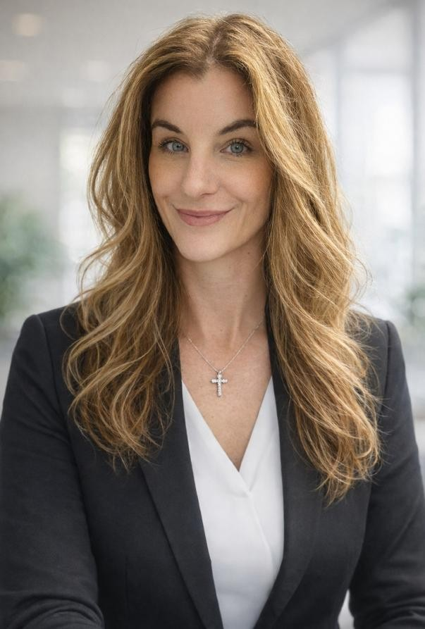
Nicole Baldwin-Hunt, MLS,
APRN, FNP-C
Medical-Legal Consultant | Professional Liability Specialist
Licensed to practice medicine nationwide
(50 States + DC)
(727) 992-4634 | Nicole@myhamiltonhealth.com

PROFESSIONAL PROFILE

Board-Certified Family Nurse Practitioner and Master of Legal Studies (Healthcare Law candidate) with over 15 years of high-acuity clinical experience. Expert in bridging the gap between complex clinical outcomes and professional liability defense strategy. Specializing in merit screening, standard of care analysis, and forensic medical record review to support litigation teams in general and professional liability matters. Uniquely qualified to provide jurisdictional insights across all 50 states, ensuring robust defense preparation for depositions, discovery, and trial.

CORE MEDICAL-LEGAL COMPETENCIES

. • Clinical Expertise: ICU, Trauma, Surgery, Cardiology, Orthopedics, Critical Care, and Emergency Medicine.
- Regulatory & Compliance: Healthcare Law, HIPAA, Risk Management, and Telehealth Statutory Requirements.
- Forensic Analysis: Independent interpretation of Orthopedic X-rays, medical chronologies, and deposition preparation.
- Jurisdictional Versatility: Active medical licensure in all 50 states + DC, providing a nationwide standard of care perspective.

EDUCATION

Master of Legal Studies – Healthcare Law | University of Oklahoma (May 2025)
Master of Science in Nursing (FNP) | South University (2018)
Bachelor of Science in Nursing | University of South Florida (2014)
Associate of Science in Nursing (RN) | Pasco-Hernando Community College (2007)

LICENSURE & CREDENTIALS

- Nationwide Authority: Active medical licensure in all 50 U.S. states and District of Columbia.
- Florida Autonomous ARNP License (#11000617).
- FNP-C, AANP Board Certified.
- ACLS, BLS, PALS Certifications.

PROFESSIONAL EXPERIENCE

Hamilton Health & Wellness / TeleHealth Connect | Founder & CEO 2019 – Present
- Compliance & Risk Management: Direct nationwide clinical operations, ensuring adherence to varying state statutes and medical board regulations across all 50 states.
- Strategic Care Modeling: Develop care delivery frameworks focused on mitigating liability in the digital health space.
Center for Bone and Joint Disease | NP – Orthopedic & Trauma Surgery 2019 – 2023
- Standard of Care Mastery: Managed high-stakes trauma and orthopedic surgical cases, ensuring meticulous documentation and adherence to surgical protocols to prevent liability.
- Diagnostic Interpretation: Conducted independent radiographic analysis and post-operative management for acute trauma populations.
Diagnostic Clinic Medical Group | NP – Internal Medicine & Urgent Care 2018-2019
- Complex Chronic Care: Delivered high-acuity primary care for adult populations, specializing in the autonomous management of multi-system chronic diseases and complex internal medicine cases.
- Acute & Pharmacological Management: Managed complex medication regimens and performed rapid assessments for urgent care presentations, prioritizing patient safety and clinical outcomes.
Acute Care & Leadership Foundations | BayCare Health / AdventHealth / Florida Hospital 2007 – 2020
- Forensic Record Identification: Over a decade of experience in high-acuity settings (ICU/Trauma/ER), providing a deep understanding of standard of care in life-or-death clinical scenarios.
- Risk Mitigation: Served in leadership roles (Interim Director/Charge Nurse), overseeing unit-level quality control and internal audit functions.

