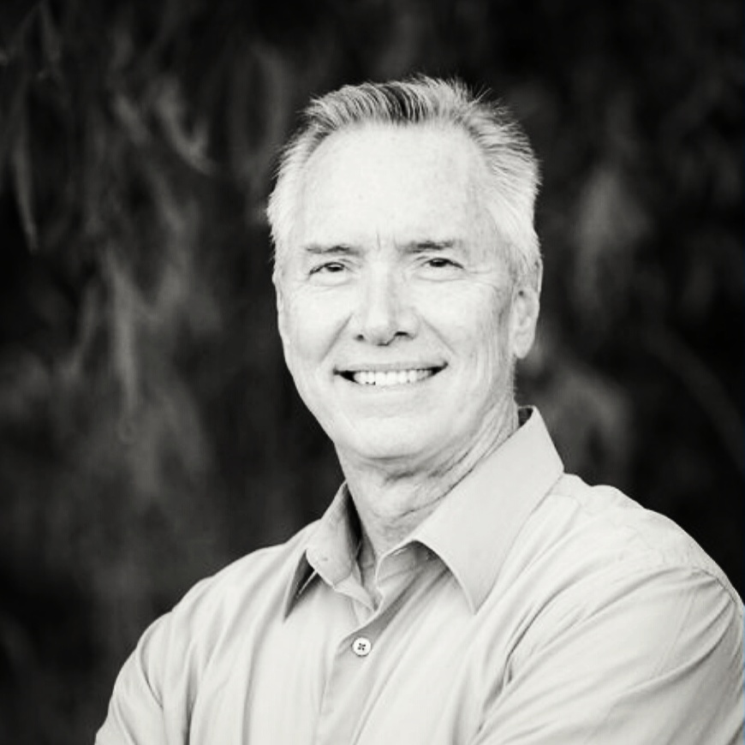
CURRICULUM VITAE:

ROBERT L. ROWE, CFI/CFEI/PI
9431 Haven Avenue, Suite 210
Rancho Cucamonga, CA 91730
Toll Free (888) 460-2879
Office (562) 261-7976
robertrowe@pyrocop.com
www.pyrocop.com

PROFESSIONAL PROFILE:

4/06 – Present

Pyrocop, Inc., President, Fire Code Consultant, Certified Fire Investigator, Private Investigator
Perform and or coordinate fire and explosion investigations in Residential, Commercial and Manufacturing facilities. Provide a complete and comprehensive third-party review of fire/explosion incidents which may include failure analysis and fire/building code review. Provide contract "Fire Marshal" services for governmental agencies which include plan review, fire/life safety inspections of commercial and residential buildings, fire alarm systems, fire protection systems and hazardous materials facilities, processes, and equipment. Provide expert witness testimony relating to fire origin and cause as well as fire and building code compliance issues. Provide fire and life safety consulting services to local fire departments.

3/07 – 01/24
FIRE SPRINKLER ADVISORY BOARD OF SOUTHERN CALIFORNIA, Executive Director
Establish and foster a working relationship with the fire service, the code enforcement community, and the public. Foster the interest of supporting members and others related to the automatic fire sprinkler industry. Engage in public relations to develop and increase consumer demand and business activities. Conduct educational programs for the fire and public officials to understand materials, techniques, and standards to improve the fire sprinkler industry. Represent the members at legislative hearings and organizational or association meetings. Engage in other activities or programs to promote the automatic fire sprinkler industry.

6/20 - Present
SMA RETROFIT TECHNOLOGIES Inc., dba SPYKE, Vice President of Product Development and Chief of Fire Operations
Provide Fire and Building Codes and Standards support, for the development of Shape Memory Alloy (SMA) heat detection technology, for residential, commercial, and marine use. Interface with subject matter experts during the design, manufacturing, and testing phases, throughout the product development process. Work closely with local, state, and federal governmental agencies and officials, to ensure all SMA products meet and exceed all applicable codes, standards, and regulations. Coordinate SMA product demonstrations, training, and educational events both nationally and internationally. Participate in applicable fire detection and fire suppression committee meetings, code hearings and/or other subject matter events.

12/89 – 3/07

City of Downey Fire Department, Deputy Fire Marshal/Fire Captain/Fire Investigator
Developed professional and technical fire safety standards under the direction of the Fire Marshal in accordance with departmental guidelines. Conducted training programs for law enforcement and fire safety personnel related to arson detection, preservation of evidence and hazardous material spill incident response. Conducted over 1000 cause and origin investigations, which includes case development and expert testimony in criminal and civil trials. Inspected commercial and residential buildings to identify fire and hazardous materials storage and handling hazards. Enforced federal, state, and local codes, references standards and ordinances related to arson, fire prevention, firework safety, hazardous materials, and other fire safety related matters.

9/80 - 12/89

Hughes Aircraft Company Fire Department, Fire Captain/Hazardous Materials Technician
Served as a Firefighter / Fire Inspector / Fire Captain and Hazardous Materials Response Coordinator for military contract facilities and projects. Provided fire suppression activities and emergency medical treatment to the sick and injured. Conducted industrial fire/life safety inspections in accordance with military policy to insure compliance with Fire Life Safety Codes and Standards as well as OSHA requirements. Supervised crew of four firefighters and one engineer. Developed and implemented the company’s fire prevention program and hazardous materials emergency response team.

COLLEGE COURSEWORK AND SUPERVISORY EXPERIENCE:

Accumulated over 3000 hours of training from various accredited colleges, with a concentrated course of study in the fire and building codes, fire investigation and hazardous materials management. Served as Fire Captain/Fire Marshal from 1985 until retirement in March of 2007.

ADDITIONAL COURSEWORK AND CERTIFICATIONS:

Fire Prevention
Fire Prevention Officer Level I, II & III- California State Fire Marshal
Fire Administration Management 2E - California State Fire Marshal
Management of Fire Prevention Programs – National Fire Academy

Fire Investigation
Licensed Private Investigator – Bureau of Security and Investigative Services PI#25454
Certified Fire Investigator – International Association of Arson Investigators Cert# 22-050721
Certified Fire and Explosion Investigator – National Association of Fire Investigators Cert# 11708-8765
Certified Fire Investigator – California Conference of Arson Investigators
Certified Fire Investigator Instructor – National Association of Fire Investigators
Fire Investigator Level I & II - California State Fire Marshal
PC 832 - Powers of Arrest /Firearms - California Peace Officer’s Commission
Post Blast Training Certification – F.B.I. / L.A. Sheriff’s Dept.
Former Special Deputy – United States Marshals Service

Hazardous Materials
Certified Hazardous Materials Technician - California State Fire Marshal
Hazardous Waste Management Training - University of Irvine
Hazardous Materials Investigations - Department of Treasury
Hazmat IC/Scene Manager - California Specialized Training Institute
Hazardous Materials Laws and Regulations - University of Riverside
Hazmat Emergency Notification and Reporting Enforcement - US EPA

RELATED AFFILIATIONS:

Executive Director of the Fire Sprinkler Advisory Board of Southern California (2007 to 2024)
Underwriters Laboratory's Technical Standards Committee for Flammable Liquid Storage Cabinets
Member of the California Conference of Arson Investigators
Member of the International Association of Arson Investigators
Member of the National Association of Fire Investigators
Member of the California State Firefighters Association’s Fire and Life Safety Committee
Past Member of the California State Fire Marshal’s Automatic Extinguishing Systems Committee
Past Member of the California State Fire Marshal’s Sprinkler Fitter’s Licensing Regulation Committee
Past Member of the California Fire & Life Safety Building Standards Advisory Board
Past Member of the NFPA1/Uniform Fire Code Development Committee
Past President of the Los Angeles Area Fire Marshals Association
Past Fire Prevention Chair for the LA Area Fire Chiefs Association
Past President of the Area “E” Arson Task Force

PRESENTATIONS/ARTICLES/ACTIVITIES:

Fire Investigation/Fire & Building Code Instructor for International Association of Arson Investigators
Contract Fire Expert for the 2017 Fire Department Evaluation Process in Abu Dhabi and Dubai
Provide on camera Fire Expertise for CNN News, HLN, Primetime Justice and other local news stations.
Currently provide fire investigation services for the City of Placentia.

Deposition and Trial Testimony Experience

Qualified and provided expert testimony at 57 depositions and 22 trials.

