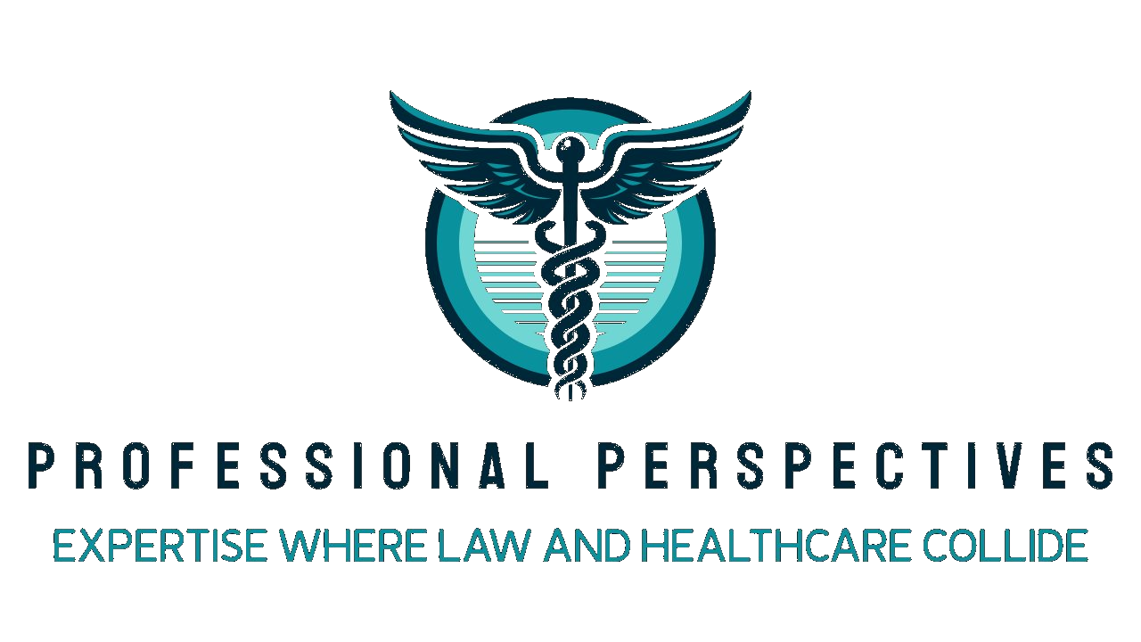 | Rebecca Edwards, MSN, B.S., RN, EMT-P  Legal Nurse Consultant | Critical Care | EMS  rebecca.edwards@professional-perspectives.com  904.403.9700 | www.professional-perspectives.com

Professional Summary

Registered Nurse and founder of Professional Perspectives, LLC, a HIPAA-compliant legal nursing consultancy. Brings over 20 years of clinical experience across critical care, trauma, pediatrics, neonatal, emergency medicine, and pre-hospital EMS to the medical-legal arena. Skilled in medical record review, standard of care analysis, causation assessment, and expert witness support. Equally fluent in rural community medicine and large academic hospital systems.
Core Competencies

• Medical Record Review & Analysis | • Standard of Care Analysis | • Causation & Damages Assessment

• Chronological Timeline Development | • Sentinel & Adverse Event Identification | • Expert Witness Support

• Hospital Policy Review | • Trauma Performance Improvement | • HIPAA-Compliant Case Management

Professional Experience
Critical Care Flight Nurse | Clinical Educator 2025 – Present
Atlas Air Ambulance
• Provides critical care transport for adult and pediatric patients in high acuity interfacility transfers.
• Serves as clinical educator supporting staff training and competency development.
Owner | Lead Consultant 2024 – Present
Professional Perspectives, LLC — Jacksonville, FL
• Founded and operates a HIPAA-compliant legal nurse consulting practice serving plaintiff and defense attorneys.
• Provides medical record review, case screening, chronology development, standard of care analysis, and expert witness support.
• Maintains a network of specialized medical professionals for case referral and expert identification.
Trauma Performance Improvement Nurse 2024 – Present
HCA Jacksonville Memorial Hospital — Jacksonville, FL
• Reviews trauma cases for quality metrics, standard of care adherence, and performance improvement initiatives.
Emergency Room | Adult ICU Nurse 2016 – 2024
HCA Orange Park | Ascension | Rural Community Hospitals
• Delivered emergency and critical care nursing across large hospital systems and rural community settings.
• Managed complex adult ICU patients including medical, surgical, and trauma populations.
• Experience in critical care transport of adult patients between facilities.
Pediatric & Neonatal Critical Care Nurse 2018 – 2024
Wolfson Children's Hospital — Jacksonville, FL
• Provided nursing care in pediatric emergency, pediatric ICU, and neonatal ICU environments.
• Performed critical care transport of pediatric and neonatal patients.
Florida Certified Paramedic | EMT 2008 – 2022
Baker County EMS | Lafayette County EMS
• Provided advanced life support pre-hospital emergency care in rural Florida counties.
• Responded to trauma, cardiac, pediatric, and multi-casualty incidents.
Certified Corrections Medical Technician 2005 – 2008
Union County CI | Florida State Prison
• Delivered medical care in a correctional setting including rapid response, urgent care, and close-custody environments.
• Provided care for death row inmates requiring complex medical management.

Education

Master of Science in Nursing – Nursing Administration
Liberty University | Lynchburg, VA
Bachelor of Science – Fire & Emergency Medical Services with Emergency Management
University of Florida | Gainesville, FL
Associate of Nursing – Registered Nurse
Florida State College of Jacksonville | Jacksonville, FL
Associate of Emergency Medical Services – EMT / Paramedic
Palm Beach State College | Lake Worth, FL

Certifications & Credentials

• State of Florida Certified Paramedic | • Trauma Nursing Core Course (TNCC)
• Advanced Cardiac Life Support (ACLS) | • Pediatric Advanced Life Support (PALS)
• Trauma After Resuscitation Certified | • Basic Life Support (BLS)

