CURRICULUM VITAE
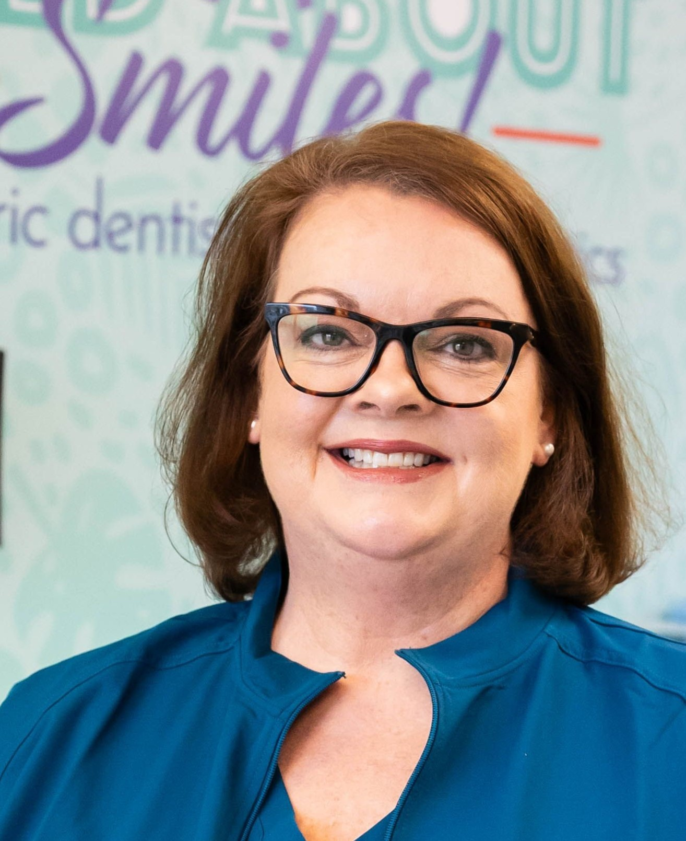

I. PERSONAL INFORMATION

A. Name: Ann “Lisa” Stanley, DMD

B. Address: 3330 Granite Springs Way
Murfreesboro, Tennessee 37130

C. Telephone (cell): 615-481-6301

D. Email: lisastanleydmd@gmail.com

II. WORK EXPERIENCE

A. Wild About Smiles! Pediatric Dentistry Pediatric Dentist
Murfreesboro and Tullahoma, Tennessee
January 2025 - current

B. Pediatric Dentistry of Lebanon Pediatric Dentist
Lebanon, Tennessee
August 2023 - December 2024

C. Cumberland Pediatric Dentistry and Orthodontics Pediatric Dentist
Murfreesboro, Tennessee
July 2020 - July 2023

(Stayed at home with children January 2011 - May 2013)

D. Wild About Smiles! Pediatric Dentistry Pediatric Dentist
Murfreesboro and Tullahoma, Tennessee
July 2005 - December 2010, June 2013 - June 2020

E. Charles A. Burdeshaw, DDS Pediatric Dentist
Lebanon and Hermitage, Tennessee
August 2004 – July 2005

F. Tennessee Department of Health, Mid-Cumberland Region
Nashville, Tennessee
December 2003 - August 2004
1. Mobile Dental Clinic
2. School Based Sealant Program

(Stayed at home with children February 2002 - December 2003)

G. United States Army Dental Corp Pediatric Dentist (contract employee)
Bamberg, Germany
July 2000 - February 2002
Provided comprehensive care for children of active duty soldiers stationed in Bamberg, Germany.

H. Baylor/Texas A&M College of Dentistry
Dallas, Texas
July 1998 - June 2000
Teaching Assistant, Department of Pediatric Dentistry

III. EDUCATION

School/Institution Degree Date Major

A. Birmingham-Southern College BS 1993 Biology/Psychology

B. University of Alabama DMD 1998 Dentistry
School of Dentistry

C. Texas A&M Health Science Center 2000 Pediatric Dentistry
Baylor College of Dentistry
Dallas, Texas

My assignments as a pediatric dental resident allowed for patient interaction at the
following facilities:

1. Children’s Medical Center of Dallas
2. Texas Scottish Rite Hospital for Children
3. Baylor/Texas A&M College of Dentistry
4. Dental Health Programs, Incorporated

IV. BOARD CERTIFICATION, CREDENTIALS, AND STATE LICENSES

State of Tennessee Board of Dentistry 2003
American Board of Pediatric Dentistry 2006
Tennessee Dental License 2003 - present
State of Mississippi Board of Dental Examiners 1998
Mississippi Dental License 1998 - present
Pediatric Advanced Life Support current
Cardiopulmonary Resuscitation current

V. SURGERY CENTER PRIVILEGES CURRENTLY HELD:

Tennessee Surgery Center, Nashville, Tennessee

Nashville Midtown Surgical, Nashville, Tennessee

VI. SOCIETY AND ORGANIZATION MEMBERSHIPS AND LEADERSHIP POSITIONS:

American Board of Pediatric Dentistry, Diplomate
~Renewal of Certification Exam Committee Member 2019 - 2021
Creates and revises examination questions for Renewal of Certification Exam

~Oral Clinical Board Examiner 2021, 2022, 2024, 2025, 2026
Administers oral board examination to board certification candidates

American Academy of Pediatric Dentistry, Fellow, Member

College of Diplomates of the American Board of Pediatric Dentistry, Member

Tennessee Academy of Pediatric Dentistry, Member

Tennessee Dental Association, Council on Dental Benefits
~Committee Member 2020 - 2023

