Layne
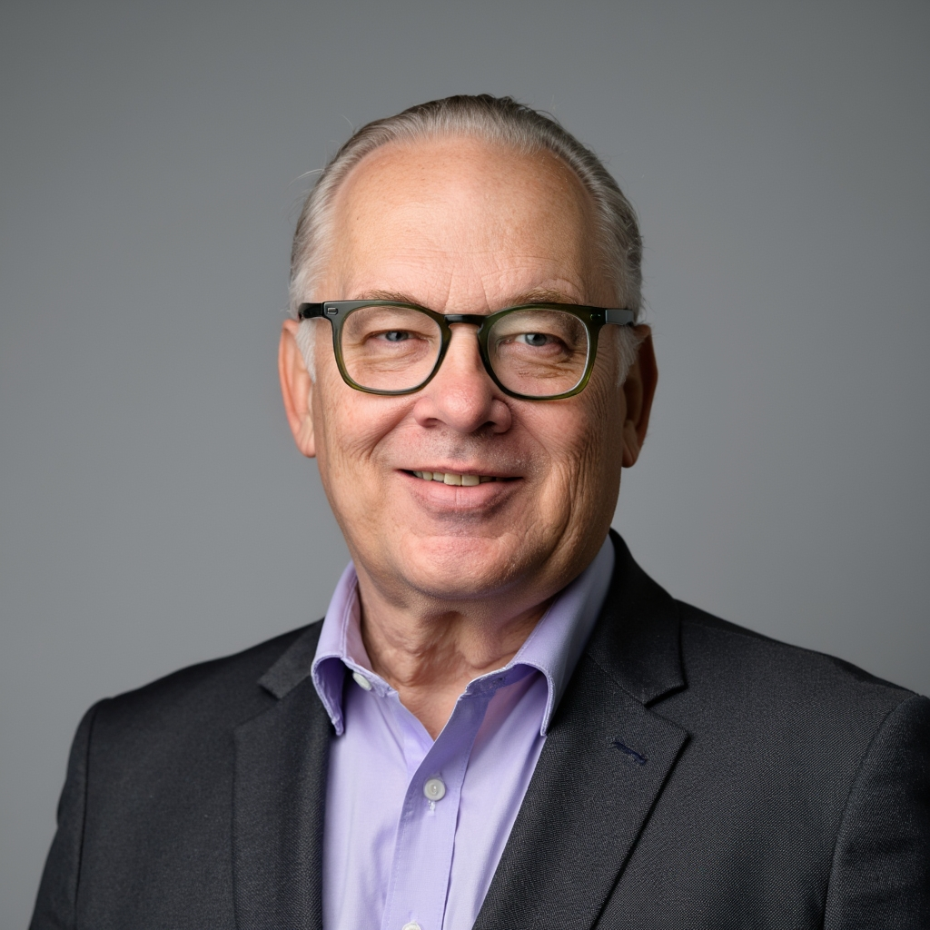

Kertamus
MA, ARM, CPCU, RIMS-CRMP

Cell: 385-237-6723
Email: Layne@InsuranceCaseConsulting.com
Address: 4373 Varner Rd.
Brownsburg, IN 46112
Located in Indiana and Utah.
Available to defense and plaintiff counsel nationwide.

Curriculum Vitae

32 years of experience in insurance, reinsurance, alternative risk as industry expert and professor.

Technical and executive experience in claims, underwriting, marketing, compliance and carrier operations.

Claims Bad Faith| Broken Insurance Transactions | Insurer Defense | Broker Standards | Property Casualty Commercial Lines Underwriting |Complex Accounts |Treaty Reinsurance |Insurer- Managing General Agent

Secured claim resolution/payments from slow pay-no pay insurance partners. Harvested reinsurance proceeds from impaired markets by commutation.

Utah State Court Rostered Mediator resolving attorney represented insurance disputes involving claims bad faith, and coverage-valuation.

Umpire and panel member in property insurance valuation disputes.

Reinsurance arbitration fact witness.

Lead faculty and full time Enterprise Risk Management and Insurance Professor.

Co-Author-Communicating the Value of ERM: The Benefits of Developing an Own Risk Solvency Assessment Report.

INDUSTRY EXPERIENCE

Insurance Case Consulting, LLC UT, and IN December 2024-Current

Expert Witness

- Providing litigation support services to attorneys on Property Casualty insurance and reinsurance matters.
- Attended Reinsurance Association of America Re Claims 2025: Navigating the World of Reinsurance Protection When Loss Strikes Seminar

Utah Valley University, Orem UT, July 2020 – August 2024
(Started new Enterprise Risk Management and Insurance (ERMI) minor at the Woodbury School of Business AACSB accredited). Utah Valley University is the largest public university in the state.

Professional in Residence
Risk Management and Insurance

Key Accountabilities/Results:

- Lead faculty member in Finance and Economics teaching all insurance content in all courses.
  - Introduction to Risk Management and Insurance - Strategic Risk, Financial Risk, Data & Decisions, Placement, Risk Classification and Exposures
  - Property Insurance and Risk Management - Property Insurance Policy types and forms, Adjuster Duties, Fraud, Loss Valuation, Special Perils, Loss Notice, Proof of Loss, Hazard Evaluation
  - Commercial Liability Risk Management and Insurance- Commercial General Liability, Business Auto Coverage, Workers Compensation, Professional Liability, Excess & Umbrella, Unique and Unusual Risks, Case Reserving, Claims Made Policies, Loss Distributions
  - Legal Environment of Insurance/Insurance Law – Conditional Contacts, Property Law, Breach, Law of Agency, creation, authority, duties, termination contractual rights, producers’ duties
  - Enterprise Risk Management – ERM Frameworks-Maturity Models, Risk Appetite, Systemic Risk, Captives, Excess Limit Structures, Loss Adjustment Expense, Adaptive Risk, Managing Post Loss Event Dynamics

- Instruction enabled students to achieve 100% job placement and 95% pass rate on national exams.
- Produced annual ERMI Conference for industry professionals in Utah. Event planning, obtained Continuing Education Credit for sessions from Utah Department of Insurance, sourced speakers, curated content, and secured sponsorships. Attendee registration of 150 insurance professionals
- Created ERMI Industry Advisory Board, selected Board Members, facilitated the Board’s work with representatives from Brokers, Insurers and Risk Management Clients/Associations
- Attended Insurtech Connect Las Vegas, 2023; RIMS Risk World 2022 and 2024; WSIA Extreme Risk Takers 2022 and 2024; Gamma Iota Sigma National Convention 2021 and 2022. Attended various risk management and CPCU events.

Utah State Court Rostered Mediator 2019 – 2023

Provided mediation services on insurance disputes independently and as a First Court Inc. mediator. Cases involved contractors, automobile accidents, premises liability, theft, and contractual breech.

Claim Rangers Public Adjuster, Payson Utah
Public Adjuster (about 2 weeks - August 2020)
Public Adjusters License, Utah - Expired

Workers Compensation Fund, Salt Lake City, UT 2012 – 2018
(A rated. Multiple line regional insurer with $2.3B in assets).
Vice President - Underwriting
Key Accountabilities/Results:
- Led underwriting department of 35 underwriting professionals. Reported to Chief Risk Officer
- Took underwriting actions using technology, training, new pricing tier structures to grow premium to $248M and achieve an underwriting profit in a highly competitive environment
- Created proprietary strategic tool to advise top management on recommended state markets for expansion
- Catastrophic Claims Committee member with legal and actuarial to set case reserves, provide direction to claim adjusters, and review next steps for vocational rehab actions
- Led team of experts to create proprietary strategic advisory tool to recommended new expansion states
- Provided input on risk appetite and positioning ceded reinsurance structure, limits, rate, terms, and allocated lines by market to achieve optimal risk appetite contemplating a terrorist or major quake event
- Reviewed broker proposals for Cyber Insurance risk placement to protect WCF’s core IT systems
- Conducted Mock NAIC “Market Conduct Underwriting Audit” to simulate and decrease forfeiture costs of non- compliance due to inconsistent file documentation
- Secured Utah Captive Management license for WCF to offer captive options to large accounts
- Reported on ERM best-practices and evaluation of internal risk maturity, risk register, and framework design
- Presented WCF’s first Own Risk Solvency Assessment (ORSA) to Board Risk Committee
- Obtained strategic insight from AASCIF insurers on all aspects of their business practices to enhance operations
- Relationship manager for Carrier and National Council of Compensation Insurance. Focused on compliance, data integrity and dispute resolution

Montana State Fund, Helena, MT 2003 – 2008
(An independent public workers compensation insurer with over 50% market share).

Vice President of Insurance Operations

Key Accountabilities/Results:
- Reported to President and CEO
- Reversed 2003 net operating loss from prior management’s deficient claim management and inadequate pricing. Increased GWP from $145M to $250M and a $37M net loss became a $28M net income due to proactive steps in claims, underwriting, marketing, and safety
- Managed $25M expense budget, effectively controlling actual vs. plan run rate funding strategic projects
- Developed Business Process Models for claims, safety, and underwriting areas to streamline customer service and standardize service quality across profit centers
- Collaborated with consulting actuarial team and claims staff to control TTD durations and contain claims cost
- Met with insureds to identify Return-to-Work opportunities for injured employees
- Responsible for providing effective leadership to 10 direct report staff and up to 100+ FTE in six business units
- Testified to state legislative subcommittee on the role of Montana State Fund’s operations in the state economy
- Responsible for Agent Advisory Council proceedings along with appointment, rehab, and termination of agents
- Decider on annual agency incentive commissions and weightings of growth, retention and profit elements
- Created claim performance dashboards to provide data informed support to adjusters
- Attended Harvard Law School’s Program On Negotiation Seminar for Executives
- Created and launched companywide six - month leadership training program for high potential employees

The Doctors Company, Napa Valley, CA
(The largest doctor owned medical professional liability insurance carrier, A rated, $7.3B in assets).

Key Accountabilities/Results: 1995-2003
Assistant Vice President

Assumed Reinsurance
- Reported to Senior Vice President & Chief Actuary and CEO
- Responsible for establishing a startup reinsurance profit center
- Grew Gross Written Premium from zero to $60M in for years by creating profit center infrastructure, consistent execution on underwriting due diligence, and sourcing new business with Global Intermediaries
- Hired, trained, and managed a direct report staff of six officers and managers

Assumed treaty reinsurance structures and client type

- Quota Share (Flat and Loss Sensitive) | - Primary Insurers/Risk Pools
- Excess of Loss | - Captives/Primary Insurers
- Property Super Cat/ILW’s | - Property Reverse Flow Retro
- Surplus Share | - Reinsurer / Professional Liability

Underwriting based on data analysis, market position, coverage grants, rate integrity, client infrastructure, accumulation, reinsurance terms, claim and underwriting audit results, actuarial and legal analysis to maximize profit and limit risk. Selectively used reinsurance as precursor to corporate acquisitions

- Lines of business include: Hospital Professional Liability, Medical Professional Liability, Allied Professional, Lawyers Professional Liability, Non-Standard Automobile, Property, Accident & Health.
- Completed Reinsurance Association of America: “The Art of Designing Reinsurance Contracts and Programs”
- Attended RIMS, Professional Liability Underwriting Society Convention, Lloyds Meet the Market, Lloyds Brokers Association, American Property Casualty Insurance Association Convention

Ceded Reinsurance
- Revitalized ceded reinsurance program to cede $80M of direct physician business to reinsurers-updated net retained lines, expanded total gross limits to $10M, secured improved terms including provisions for Excess of Policy Limits, XPL and Extra Contractual Limits, ECO to protect core business and flexibility on claims settlement
- Responded to Reservation of Rights letters on ceded claims from reinsurers to secure recovery
- Secured reinsurance documentation to qualify for ceded reinsurance credit on Financial Statements
- Collateralized alien reinsurance participations using evergreen Letters of Credit where required
- Assisted clients in devising capitated compensation plans of defense attorneys on accounts over $4M in income
- Established new Hospital Professional Liability ceded program to provide $50M in policy limits for TDC and the California Hospital Insurance Company Risk Retention Group (CHIC, RRG), to write larger risks
- Oversaw renewal submission and placement process to multiple domestic and London based brokers consistent with TDC’s approach the market
- Wrote and implemented TDC intercompany pooling agreement for Underwriter for the Professions (UFTP), and Professional Underwriting Insurance Company (PULIC) subsidiaries to maintain their AM Best Rating
- Facilitated underwriting and claim audits and dialogue with ceded reinsurers
- Audit responses to CA Department of Insurance for 3 - year Statutory Audit of business practices

Alternative Risk
- Issued admitted and non-admitted insurance policies on niche business produced and managed by Managing General Agents (MGA)
- Simulated optimal combinations of issuing fee income, net retention, expected loss ratio, and investment income on gross, net and ceded basis as a foundation of negotiating successful program arrangements
- Evaluated partner’s business plan, IT capabilities, entry strategy, quality of underwriting talent, financial strength, and program track record
- Wrote Program Management Agreements. Approved delegation of letter of underwriting authority, placed individual program specific reinsurance protections, audited claims and underwriting practices
- Solved contractual, financial and competence-based problems arising on delegated programs

USF Re Insurance Company, Costa Mesa, CA 1987-1995
- Rated start up Property Casualty Reinsurer, now part of AXA Reinsurance Corporation)

Key Accountabilities/Results:
Assistant Vice President
- Reported to Vice President of Underwriting. Hired as first desk underwriter in pre-IPO reinsurance company
- Underwrote facultative risks nationwide with 20 intermediaries such as: Aon, A.J. Gallagher, Guy Carpenter etc.
- Underwrote 1200 submissions per year including Fortune 500 accounts
- Lines of business included: General Liability, Auto Liability, Excess and Umbrella liability
- Provided working layer and high attachment coverage over Self Insured Retentions, deductibles, for Trucking, Schools, Municipality, Contractors, Products, Habitational, and Manufacturing accounts
- Risk selection based on exposure underwriting loss history of open and closed claims, and basic on level trend and development analysis to estimate ultimate loss values. Venue grading based on litigation climate in state
- Analyzed ceding company statutory financial statements to determine client acceptability
- Attended WSIA, and RIMS conventions
- Completed Dr. Robert Strain’s “Reinsurance Claims and Insurance Company Litigation Course”

Hartford Insurance Group, Diamond Bar, CA 1985-1987
Key Accountabilities/Results:

Commercial Casualty Underwriter
- Completed formal training commercial underwriting training program in a cohort of 10 trainees.
- Upon completion of training, responsible for loss analysis, hazard control, pricing, selecting target casualty business in $4.2M territory in Southern California
- Implemented agency marketing plan to increase business by 30%
- Focused on General Liability, Commercial Auto, Workers Compensation and Umbrella products
- Earned the Institute’s Associate in General Insurance Services designation.

EDUCATION

California State University, Fullerton 1992
Master of Arts, Intercultural Communication

California State University, Los Angeles 1985
Business Courses

Claremont Mckenna College, 1983
Bachelor of Arts, Economics

Citrus Community College 1980
General Studies

Harvard Kennedy School – Executive Education 2007
The Art and Practice of Leadership Development – A Master Course

Oxford University, Rewley House Continuing Ed 1980
Certificate – International Economics

EARNED QUALIFICATIONS

Advance HE
Associate Fellow, AFHEA 2023
https://www.advance-he.ac.uk/

The Institutes – Professional Designations
Associate in Risk Management, ARM 2017
Chartered Property Casualty Underwriter, CPCU 2007
Associate in General Insurance 1986

Risk & Insurance Management Society
RIMS - Certified Risk Management Professional, CRMP 2022

PRESENTATIONS

- LGIM America Seeing the Unseen: Neurodiversity in the Workplace Chicago, 2024

- 6th Annual International Teaching Forum. AI as an All Modality Teaching Space Maker L'Université Clermont Auvergne, France; Shanghai Normal University, China; Utah Valley University, 2023

- The Other AI: Using Appreciative Inquiry to teach Enterprise Risk Management in Higher Education, Southern Risk Management Association, New Orleans 2022

- Risk Management Monitor RIMS ERM Conference: A Case-Study Approach to “Solve Any DEI Issue in One Hour” NYC and Virtual, 2021

- Economic Development Corporation of Utah, EDCU, UVU’s Risk Management and Insurance Minor – You can Ignore Risk Management and Insurance but it Won’t Ignore You 2021

- Stoel Reeves Enterprise Risk Management Symposium – Moderator, Panel on Health Care Reform, Salt Lake City, 2017

- American Association State Compensation Insurance Funds National Conference - Moderator Panel on The Internet of Things, Salt Lake City, Utah, 2016

- American Association State Compensation Insurance Funds, Super Conference – Presentation Delighting Customers Thru Effective Negotiation, Columbia, South Carolina, 2014

- Fred Pryor Seminars: Trainer for a wide variety of business seminars nationwide. 2008-2012

- Verus Global Pathways to Leadership Facilitator in Training Denver, 2011

- Arizona Society of CPCU’s I Day Conference Insurance Negotiation Keynote and Adaptive Leadership Breakout Pheonix, 2008

- Workers Compensation Research Institute, Workers Compensation in Montana: Administrative Review, Ballantyne D. 2007 (Cited as Contributor) Boston, 2007

- International Communication Association Annual Conference, Japanese-North American Negotiation Themes, Washington DC., 1993

Neurodiversity Presentations Below - (some neurodiversity presentations are unlisted)

- Work Wonder and Wellness, Autcon Conference ScenicView Academy 2020

- Leading with Impact: The Imperative of Neurodiversity Diversity Best Practices | EmERGe West Conference| Working Mother Media, San Fransico, 2019

- Neurodiversity at Work: Works Best, TEDx Rexburg Talk, 2019

MEDIA MENTIONS

-Insurance Related Media-

- The Street Why Property Casualty Insurance Should Not Be Optimal by Brian O’Connell, 2023 quoted
https://www.thestreet.com/personal-finance/why-property-casualty-insurance-should-not-be-optional-14582984

- Southern Risk and Insurance Association 55th Annual Meeting The Other AI: Appreciative Inquiry (AI) as an Approach to Teaching Enterprise Risk Management in Higher Education Layne Kertamus, Utah Valley University, New Orleans, 2022 https://southernrisk.org/wp-content/uploads/2023/05/SRIA_2022_Program.pdf

- Rough Notes Company Inc., Lessons Learned Education experiences during the pandemic can help bolster professional development By Dave Willis, CPIA, 2022 interviewed https://roughnotes.com/lessons-learned/

- UVU Woodbury School of Business Deans Report 2021-2022

- UVU Woodbury School of Business Risk Management Program, 2020 https://www.uvu.edu/woodbury/news/2020/riskmanminor.html

- Jamestown Sun Today Interim WSI CEO Interviews Jamestown Sun Today, 2008

- Guidewire Montana State Fund Reports Successful Guidewire Implementation Guidewire Claim Center®
brings business value to state's largest workers' compensation insurer, 2007 quoted

8. Montana Major IT Project Portfolio as of 12.1.2005 Legislative Finance Committee - Claims Center Project

-Separate from Insurance Industry-

- Up Journey What to Put for Desired Salary on a Job Application (According to 10 Managers and HR\\ Experts), 2024 quoted

- My Life Decisions Topic 5 Navigating Employment, 2024 quoted
https://mylifemydecisions.org/wp-content/uploads/2024/07/Topic-5-Navigating-employment.pdf

- Montana Free Press Law Makers Deadlock on Commissioner of Political Practices Commissioner Alex Sakariasson, mentioned, 2023
https://montanafreepress.org/2023/01/03/commissioner-political-practices-mangan-replacement/

- Utah Business Roundtable Diversity Equity and Inclusion, 2023, 2022 and 2021 quoted
https://www.utahbusiness.com/qa/2023/08/14/roundtable-diversity-equity-and-inclusion/

- Voice of Islam.Co.UK Radio Interview Farah Mirzah, 2022 interviewed
https://soundcloud.com/voislam/drive-time-show-podcast-22-11-2022-neurodiversity-and-childrens-happiness- or-resilience?in=voislam/sets/drive-time-show-archived-2021-2022

- BYU Radio The Lisa Valentine Clark Show Autism in the Workplace, Interview, 2019

- EPN News Is Diversity Your Company’s Secret Weapon for Success? Interview, 2019

- Access People HR Learning & Development Are all HR professionals incompetent? 2019 quoted

- Training Industry Career Pathways in L&D: The Path to Chief Diversity and Inclusion Officer Taryn Oesch, 2019 quoted
https://trainingindustry.com/articles/professional-development/the-path-to-chief-diversity-and-inclusion-officer/

SEPARATE EXPERIENCE

AsperianNation.com Salt Lake City, UT 2018 – current
- Owner. Provider of neuroinclusive wellness culture solutions to employers.

Utah State Society of Human Resource Management SHRM 2020 - 2022
- Board Member at Large – Volunteer.

NegotiGator, Helena, MT 2008 – 2012
- Owner. Provided up to 100 annual training and facilitated sessions nationwide as subcontractor for Pryor Seminars.

University of Montana, Helena College of Technology 2009
- Adjunct Instructor teaching Developmental English and Introduction to Public Speaking.

Stop DUI Task Force Helena, MT 2004
- Appointed by the Lewis & Clark County Commissioners to decrease impaired driving.

US Presidential Appointee, Glendora, CA 1996-2000
- Appointed by President George H. W. Bush to non-partisan local volunteer board.

UNOCAL Corporation, Los Angeles, CA 1985
- Document clerk processing cancellation/issuance of UNOCAL common stock transfer.

E F Hutton & Co., Los Angeles, CA 1984
- Regional Futures Specialist advising brokers on futures markets.

Merrill Lynch Fenner Pierce & Smith, San Marino, CA 1983
- Account executive serving retail customers.

Lewis, D’Amato, Brisbois & Bisgaard, Los Angeles, CA 1981 & 1982
Summer
- Litigation support summarizing 100’s of pages of Billionaire Howard Hughes’ handwritten notes to his personal attorneys and staff.

