Michael P Menz, CIH, CHMM
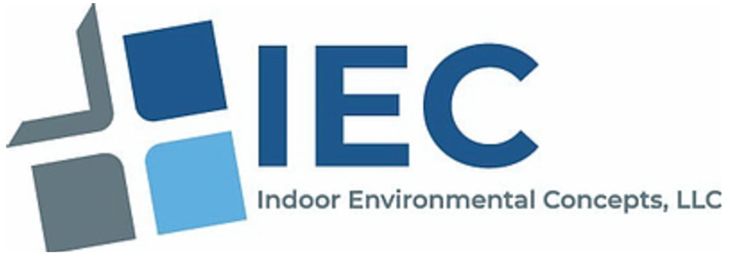
Principal | mpmenz@indoorenvconcepts.com
Licenses and Certifications
- ABIH Certified Industrial Hygienist (#18297)
- IHMM Certified Hazardous Materials Manager (#20307)
- IICRC Water Damage Restoration Technician (#67274075)
- Asbestos & Mold Trainer (Pennsylvania, New York, Florida)
- New York State DOL Asbestos Inspector Certification #13-18853, Ex. 8/2023
- PA Asbestos Inspector/Management Planner Certification #003131 Ex. 12/1/2026
- PA Asbestos Project Designer #003131 Ex. 11/7/2026
- City Of Philadelphia Asbestos Investigator Certification #AIC-0071 Ex. 3/31/2027
- City Of Philadelphia Asbestos Project Inspector #API901-0152 Ex. 05/31/2026
- EPA Lead Dust Sampling Technician Certification No. D-1-18846-24-00009 Ex. 1/10/2030
- ASSE 12080 Legionella Water Safety and Management Specialist
Career Experience
Indoor Environmental Concepts, LLC / Menz Industrial Hygiene Services
2011 – Present | Principal
- Provide high-quality industrial hygiene services and environmental consulting to a diverse range of clientele.
- Match services with unique client needs and deliver services including Indoor Environmental Evaluations (IEQ), Asbestos Investigations, Silica Exposure Assessments, Mercury in Rubberized Gymnasium Flooring Management, Lead-based Paint Consultations, Dust Examination Clearances, Hazardous Waste Inventories, and more.
- Consistently recognized by clients for delivering exceptional services and ongoing support.
- Prepare and deliver client-specific sampling strategies and interpret the results of all samples.
- Perform asbestos investigations of commercial, industrial, and educational buildings.
- Prepare asbestos abatement project design specifications and work plans.
- Conducts indoor environmental quality assessments including moisture evaluations, infrared imaging, micro-organism sampling, and ventilation system evaluation.
- Performs industrial hygiene vapor exposure assessments and local exhaust ventilation system consultation.
- Conducts hazardous waste classification sampling and report interpretation.
- Supports litigation for industrial hygiene cases including asbestos, fungal and water damage, legionella, carbon monoxide cases, and lead-based paint cases as an expert witness.
- Prepare and review site specific Health and Safety Plans.

EMSL Analytical, Inc.
2012 – 2019 | Environmental, Health & Safety Manager / Radiation Safety Officer
- Delivered a host of environmental and industrial hygiene solutions and training classes spanning EPA Asbestos Inspection and Management Planning, NIOSH 582 Equivalency, Indoor Air Quality, Industrial Hygiene Sampling, Mold Assessor Training, and other key topics.
- Created and integrated best practice and proactive safety and regulatory methodologies.
- Managed all aspects of hazardous waste disposal programs for large quantity generator and branch laboratories, including elemental neutralization and waste minimalization.
- Directly collaborated with facility management and engineering leaders to design new laboratory spaces for engineering controls, emergency showers, and fire suppression systems.
- Provided in-house training to new hires and annual refresher training to all cross-functional staff.
- Oversaw the purchasing and safe storage of compressed gases and an inventory of flammables and oxidizers.
- Recognized by clients for providing high-quality and customized technical support across sampling procedures, data interpretation, regulatory compliance, and other critical areas.
- Managed multiple additional programs, including a radiation safety program, a hood and instrument calibration program, and other emerging programs as needed.
Synertech, Inc.
1990 – 2010 | General Manager
- Oversaw the daily operations and strategic priorities of an environmental consulting company which provided a host of field services, including Right to Know compliance, indoor air quality investigations, industrial hygiene assessments, asbestos inspection and design, lead based paint testing, and hazard communication.
- Led and mentored a 17-member staff and efficiently managed average annual sales of $2.25M.
- Served as the primary point of contact for clients and ensured the provision of quality and cost-effective work.
- Prepared specialized contract documents and managed large-scale remediation projects associated with site decommissioning.
- Managed an in-house phase contrast microscopy laboratory quality control program while simultaneously interpreting analytical results and recommending corrective action and cost analysis strategies.
- Liaised directly with the EPA, DEP, OSHA, Philadelphia Department of Health, and Philadelphia Department of Licenses and Inspections.
- Recognized for delivering high-quality solutions for large-scale clients, including the Philadelphia School District, Philadelphia Housing Authority, Rohm and Haas Company, LaSalle University, Mercy Hospital of Philadelphia, U.S. Naval Public Works, Chestnut Hill Hospital, Roxborough Hospital, and the Trigen-Philadelphia Energy Corp.
Additional Career Experience:
- Environmental Trainer, Pennsylvania & New Jersey
- AIHA appointed member to ASTM Committee D22.08- Assessment, Sampling, and Analysis of Microorganisms
- Technical Contact for ASTM D7338-14 (2023) Standard Guide for Assessment of Fungal Growth in Buildings
- Philadelphia Section AIHA Director, 2024-current
- Senior Project Manager, Probe Environmental, Inc.
- Product Coordinator, Wheaton Scientific

Education
- Environmental Engineering, Environmental Chemistry, & Education Studies, Villanova University & Drexel University
- Bachelor of Science in General Scientific Studies, Villanova University
Continued Training and Professional Development:
- Hazardous Waste Management & Mold/Moisture Remediation Studies, Rutgers University Cook College
- Comprehensive Industrial Hygiene Course, AIHA / University of Michigan
- Asbestos Project Design Training, Temple University
- Improving Construction Documents & Specifications, Construction Specifications Institute
- Radiation Protection Standards, Porter Consultants, Inc.
- Concepts & Strategies of Radon Measurement, DERA / AARST
- Lead Abatement Training for Supervisors & Contractors, Leadtec Services, Inc.
- EPA RRP Lead Renovator & Dust Sampling Technician, Access Training Services
- Radiation Safety Officer with DOT Certification, Dade Moeller Training Academy
- DOT, NRC, & IATA Requirements for Shipping Radioactive Materials, Dade Moeller Training Academy
- 40-Hour Hazardous Waste Operations & Emergency Response Training, PTP Consulting, Inc.
- Pennsylvania Certified Asbestos, Lead, & Hazardous Waste Operations Instructor
- IICRC Water Damage Restoration Technician, Reets Drying Academy
- Certified Residential Thermographer, Monroe Infrared Technology
- Making Accurate Exposure Risk Decisions, AIHA University
- Use of Direct Reading Instruments Certificate Program, AIHA University
- Certificate in Noise and Hearing Loss Prevention, ACGIH Learning Program

Professional Affiliations and Memberships
- American Industrial Hygiene Association (AIHA), National Full Member and Member of local chapters; New Jersey, NY Metro and Philadelphia sections
- Institute of Hazardous Materials Management (IHMM)
- Institute of Inspection Cleaning and Restoration (IICRC)
- American Conference of Government Industrial Hygienists
Publications, Presentations and Speaking Engagements
- Indoor Air Concerns, Today’s Facility Manager (November 2013)
- Asbestos Inspections and Mold Assessments Involving Confined Space Entry
Environmental Information Association (EIA) National Conference, March 28, 2023
- De-Regulation of Asbestos Floor Tile Removal using Dry-Ice?
Environmental Information Association (EIA) National Conference, March 22, 2022
- Mercury in Rubberized Flooring
Environmental Information Association (EIA) National Conference, March 2021
- Mercury in Rubberized Flooring- Risk vs. Reality
American Industrial Hygiene Conference & Expo (AIHce), May 2020
- Mitigating Emerging Hazards: Mercury Floor Abatement
New Jersey Education Association (NJEA) Convention, November 2019
- The New Silica Rules and Silica Laboratory Analysis
Pennsylvania Governor’s Safety Conference, October 2018
- Laboratory Considerations for the Analysis of Radiologically Contaminated IH Samples
AIHce, May 2018
- Laboratory Ventilation- Impact on the Building Environment
AIHce, May 2018
- Mold Exposure, Assessment, and Prevention
ASHI / InspectionWorld, January 2018
- Sampling and Laboratory Issues within Environmental and Occupational Safety
Georgia Safety, Health & Environmental Conference, September 2015
- Industrial Hygiene Issues from a Lab Perspective
Georgia Local AIHA Section, April 2016
- NYS Mold Licensing Standard and Comparison to Other State
New York Metro AIHA, September 2015

