Brian T. Hart DDS

Board Certified Oral and Maxillofacial Surgeon

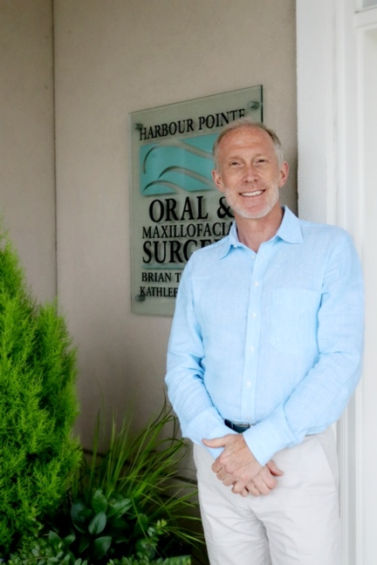

Dr. Hart has been in practice for over 34 years, spending 26 of those years in private practice in the greater Seattle area. In addition, he has been an Affiliate professor at both Harbor-UCLA Medical Center and the University of Washington School of Dentistry. He is an active member of the American Association of Dental Consultants and continues to clinically practice part time. Dr. Hart also participates in volunteer missions around the world with the Global Dental Relief Foundation.

Education
- University of Washington, BA History, 1978 - 1983
- Georgetown University, Doctor of Dental Surgery, Cum Laude, 1983-1987
- Hospital zum Heiligen Geist, Oral Surgery Externship, 1987-1989
- Harbor-UCLA Medical Center, Oral and Maxillofacial Surgery Residency
1989-1993

Experience
- Harbor UCLA Medical Center, Associate Clinical Professor, 1993-1995
- Puget Sound Oral and Maxillofacial Surgery, Owner/Surgeon, 1995-2018
- University of Washington, Affiliate Assistant Professor, 1996-2011
- Harbour Pointe Oral and Maxillofacial Surgery, Founder/Surgeon, 1997-2021
- Dental Care Seattle, Oral Surgeon, 2023-current
- Roosevelt Dental Center, Oral Surgeon, 2023-Current

Past (P) and Current (C) Memberships/Associations
- Member, American Association of Oral and Maxillofacial Surgery (C)
- Diplomate, National Dental Board of Anesthesiology (C)
- Diplomate, American Board of Oral and Maxillofacial Surgery (C)
- Member, American Association of Dental Consultants (C)
- Member, American College of Oral and Maxillofacial Surgeons (P)
- Member, American Dental Association (P)
- Member, Washington State Dental Association (P)
- Member, Washington State Society of Oral and Maxillofacial Surgeons (P)
- Member, California Association of Oral and Maxillofacial Surgeons (P)
- Member, Academy of Osseointegration (P)
- Member, American Society of Dental Anesthesiologists (P)
- Co-Founder, Greater Seattle Multidisciplinary Study Club (P)
- Member, International Congress of Oral Implantologists (P)

Areas of Clinical Expertise
- Dental extractions and wisdom teeth
- Dental implants
- Dental anesthesiology
- Bone grafting/sinus lift grafting
- Medical assessment of the dental patient
- Diagnosis of oral pathology (both benign and malignant)
- Radiographic evaluation of the teeth and jaws
- Osteonecrosis of the jaws
- Dental and facial trauma
- Dental pharmacology
- Infections of the teeth and jaws

