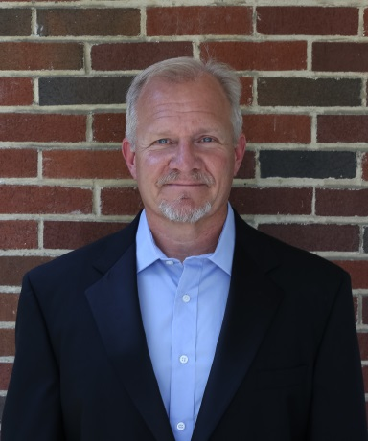**SCOTT LUSSIER**

scott@oakwoodtcp.com

613 Woodhall Drive, Willow Street, PA 17584

Cell: 717-283-6317

www.oakwoodtcp.com

**SUMMARY of EXPERTISE**

Over 30 years of Green Industry expertise in all phases of tree care, including 18 years consulting with clients to diagnose tree health and safety concerns. Specializing in discovering causation, appraisal valuations, and expert witness services.

**EMPLOYMENT**

**Oakwood Tree Care Professionals, Inc.** | Willow Street, PA 17584

*President* 2005 – present

* Expert witness
* Perform risk analysis for hazardous trees
* Develop plant appraisal valuations for trees
* Provide all phases of tree care for commercial and multi-million dollar residential properties
* Develop long-term tree care plans
* Install ornamental light displays in trees

**Longwood Gardens** | Kennett Square, PA 19348

*Senior Arborist and Pesticide Applicator* 1999 – 2005

* Cared for trees in all phases at the World’s Largest Display garden
* Taught Arboriculture to the Professional Gardener training program students
* Taught ‘Planting Trees’ and ‘How to Prune Small Trees’ for the Continuing Education Dept.
* Was a lab instructor for Certificate of Merit series for all Tree ID classes
* Sculpted and maintained topiary garden collection
* Installed world premier Christmas light display

**Asplundh Tree Expert Co** | Willow Grove, PA 19090

*Top-rate Climber* 1998 – 1999

* Trimmed trees away from high power electric lines

**Keystone Tree Experts** | Doylestown, PA 18901

*Pesticide Applicator* 1997 – 1998

* Diagnosed and treated insect and disease problems on trees
* Responsible for sales

**Henkels and McCoy** | Blue Bell, PA 19422

*Contracted Utility Forester* 1996 – 1997

* Utility Forester contracted to Met-Ed First Energy and PECO Energy
* Responsible for contacting customers to discuss tree pruning schedules
* Managed contracted Asplundh Tree Expert crews to prune trees away from electric wires

**Strathmeyer Forests, Inc.** | Dover, PA 17315

*Field Production Manager* 1992 – 1996

* Responsible for all phases of Christmas tree production
* Managed crews of 25 employees, primarily Spanish-speaking
* Learned to speak Spanish

**Witman Landscaping** | York, PA 17403

*Landscaper* 1991 – 1992

* Maintained lawn and gardens for residential properties
* Pruned and planted shrubs and trees of all sizes

**EDUCATION**

Penn State University

1990 BS in Forestry Science

**CERTIFICATIONS**

* International Society of Arboriculture (ISA) Board Certified Master Arborist (BCMA) - #PD-0358B
* American Society of Consulting Arborists (ASCA) Registered Consulting Arborist (RCA) - #447
* Longwood Gardens Certificate of Merit in Ornamental Plants Series I & II