Curriculum Vitae 30338 Laurelwood Lane grriehle@riehlelaw.com
GREGORY R. RIEHLE Wesley Chapel, FL 33543 griehle@gmail.com

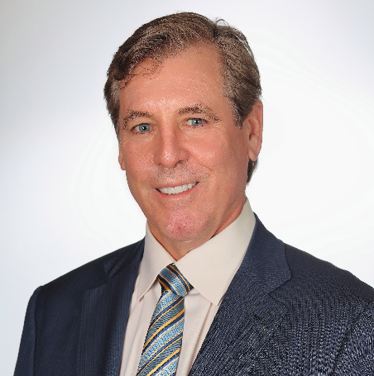
Mr. Riehle accepts expert witness retentions, appointments as a mediator or arbitrator, and general consulting in hospitality industry matters.

WORK HISTORY
2019-Present: Riehle Hospitality Consulting – Legal and Operations
2014-2018: President and Chief Executive Officer-Resort Hotel Association/Resort Hotel Insurance Company (www.rhainsure.com)
1989 –2014; 2020-Present: Saddlebrook Resorts, Inc. and affiliates (managed of sale of destination resort in 2022) (www.saddlebrook.com)
Positions held:
1998-2014: Executive Vice President and General Counsel – Saddlebrook Holdings, Inc.2002 - 2007
2007 – 2012: General Manager and EVP: Saddlebrook Resorts, Inc.
1992 - 2002 President – Saddlebrook Sports (Saddlebrook International Tennis, Saddlebrook Preparatory School, Arnold Palmer Golf Academy)
1989 – 1992 Vice President / General Counsel
1982 – 1989 Attorney in Private Practice
1987 – 1989 Shumaker, Loop & Kendrick Tampa, Florida
1984 – 1986 Schramm & Raddue Santa Barbara, California
1982 – 1984 Squire Patton Boggs Cleveland, Ohio (formerly, Squire Sanders & Dempsey)

OTHER POSITIONS
Florida Supreme Court Appointed Arbitrator
Florida Certified Mediator
Resort Hotel Association and Resort Hotel Insurance Company
1992 -1998 and 2013 – 2014, Chairman
1992 – 2014, Director and Secretary
Hillsborough County (Tampa) Hotel-Motel Assn. President 2008 - 2010
Board 2007 – 2014; Director Emeritus 2023 - Present
Pasco County (FL) Tourist Development Council 2007- 2014
Visit Tampa Bay (CVB) Board and Executive Committee: 2007- 2014; Treasurer Tampa Bay Sports Commission, 2012- 2014
Florida Restaurant and Lodging Assn., Board and Governmental Relations Committee, 2006-2013
Florida House of Representatives, Employer-Sponsored Benefits Task Force 2013-14
American Hotel and Lodging Association, Resort Committee 2014-2018
American Hotel and Lodging Association, Risk Management Committee, 2014-2018
St. Leo University Hospitality Council 2008-2012
Cornell University 5th Annual Hospitality Law Institute, New York, NY
October 2002 – Lead Panelist: Force Majeure Clauses in Hotel Group Sales Contracts
Villaggio at Tierra Verde, a condominium: President 2006-2009, Director 2005-2011
Saddlebrook Resort Condominium Association: Director 2007-2012
Bella Verde Community Development Districts (Golf, Lake, and East) Board of Supervisors: 2004-2010
Pasco County (FL) Bar Association: President 1991

EDUCATION:
University of Southern California Law School
Juris Doctor, 1982
University of Notre Dame
Bachelor of Arts, With Honors, 1979
Cornell University School of Hotel Administration
General Managers Program, 2001
Cornell University Managerial Accounting Certification, 2000

BAR ADMISSIONS
Florida (active); California and Ohio (inactive)

EXPERT WITNESS ENGAGEMENTS
* Giacalone v. MedicWest Ambulance, Inc., Case No. A-15-714139-C (NV, Clark) (standard of care of convention operator to prevent allergic personal injury to trade booth worker)
* BH v. Roosevelt Inn LLC, et al., February Term 2019, No. 03356; CA v. Roosevelt Inn LLC, et al., February Term 2019, No. 03355; KC v. 4200 Roosevelt LLC, et al, January Term 2021, No. 01926; TE v. 4200 Roosevelt, LLC, et al, September Term 2020, No. 00994; VS v. 4200 Roosevelt LLC, et al, September Term 2020, No. 00997. Standard of care involving human trafficking in hotels.
* Repsher & Muffintop v. Easton Hotel Restoration, Case C48-CV-2021-00163 (PA, Northampton) (hotel concession contract interpretation.
*Arena Ltd, v. Packard Hospitality Mgmt., Case 2021-CA-001622 (FL, Duval) (interpretation of management company obligations to hotel owner’s lender)

Recent Notable Speaking Engagements
- Podcast: http://lodgingleaders.com/280 “Premium Letdown: Hotels Challenge Property Insurers’ Refusal to Cover COVID-19 Revenue Loss.” Release Date: 8/5/20
- Moderator, Cayuga Hospitality Consultants Annual Conference, April 2019, Toronto, CA, “Marijuana in Hotel Industry.”

