CURRICULUM VITAE

Eric M. MacDonald
President/Lead Consultant
Apex Dive Safety and Compliance
4600 Misty Lane
Panama City, FL 32444
(808) 398-4215
apexdivesafety@gmail.com
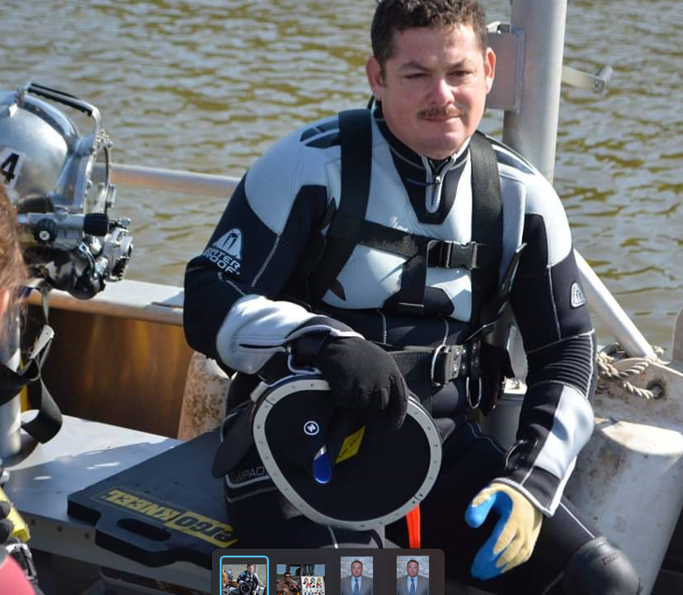
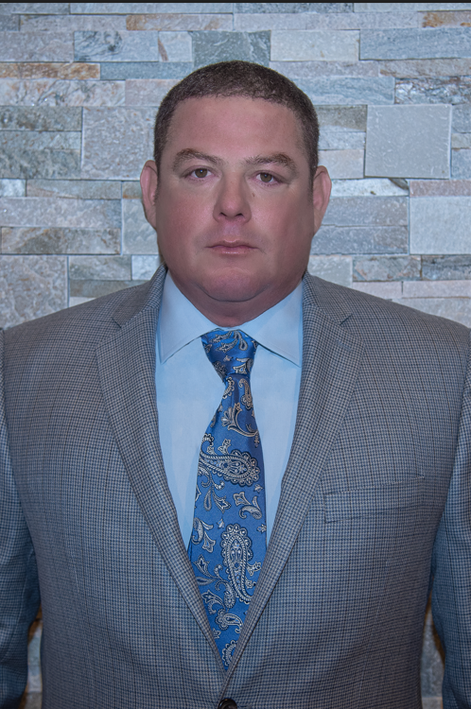

Formally trained expert witness. 33 years of military, commercial, and recreational dive supervisory experience. Currently dive systems, safety, training, and compliance consultant. Master of Science (MS) in Occupational Safety and Health. Retired US Navy diver, earned the rank of Chief Warrant Officer Five (CWO5).

Current Position
President/lead Consultant (2020-Present)
Apex Dive Safety and Compliance, LLC
Panama City, FL
www.

Professional Experience
Project Manager, PROTEQ, Maritime Technology and Operations. (Feb 2024-present)
Project Manager and maritime/diving safety expert.

Consultant, Copper Collar Group, LLC (May 2019-Jan 2023)
Full-service dive safety and hazardous operations consultants.
- Drafted “safe dive plans” for unique or very hazardous dive operations
- Researched issues of law regarding OSHA regulations for commercial and scientific dive industry drafted recommendations and dive plans regarding same
- Completed extensive compliance reviews for commercial, recreational, and Emergency Management Service (EMS) dive regulations, policy, and operating parameters
Occupational Safety Manager, ATOR Labs (Jan 2019-May 2019)
Develop and test cutting edge Respiratory equipment for diving, aviation, military, and EMS use.
- Assisted in construction and sale of Automated Breathing Metabolic Simulators
- Assisted in development, testing, and construction of Automated Dive equipment test stands
Training Manager, USN Center for Diving and Explosive Ordinance Disposal ( Jan 2017 to Nov 2019)
- Personnel Qualification Standard (PQS) certification manager. Developed and published 2500 job task standards for the entire 4500-person Navy dive community.
- High Risk Training Safety Officer/instructor for over 500 dive students per year.
- Dive unit material maintenance manager and inspector. Ensured 98% compliance for over 6 million dollars in certified dive life support and ancillary equipment.
Fleet Liaison, Naval Sea Systems Command (NAVSEA), Washington, DC ( Jan 2014 to Jan 2017)
- Fleet wide Dive material, operational and Safety Inspection team leader.
- Navy Inspector General (IG) inspection team member.
- Fleet Diving, Salvage, Ship Repair Technical authority.
- Updated US Navy Dive Manual and all technical publications.
- Conducted Navy wide MK-16 Closed Circuit failure analysis and root cause investigation.

Department Head, USN Regional Ship Repair Facility (SWRMC), San Diego (Jan 2011 to Jan 2014)
- Managed 100 military and DOD civilian divers at three different locations
- Highest number of dives of any USN unit, maintained 70-million-dollar repair budget
- Dive Safety Officer for the base, recompression chamber Diving Officer for region
- Oversaw the repair of over ten surface combatants, eight nuclear submarines, and two aircraft carriers
- Critique and Root Cause accident/incident investigation chairperson
Division Head, Naval Undersea Warfare Center, Keyport WA (Jan 2008 to Jan 2011)
- Conducted undersea warfare research and development of cutting-edge weapons systems
- Maintained the regional emergency recompression chamber conducted bends case treatments.
- Conducted Dive Safety Oversight (DSO) for US Army Corps of Engineers contract work.
Division Head, Puget Sound and Pearl Harbor Naval Shipyards (Jan 2005 to Jan 2008)
- Managed over 75 military and DOD Civilian divers servicing Navy ships and submarines
- Conducted over 20 Root Cause investigations for accidents and procedural errors.
- Implemented policy that significantly reduced near misses and accidents
Officer in Charge, Mobile Diving and Salvage Unit ONE, Pearl Harbor Hawaii. (Jan 2000 to Jan 2005)
- Invaded Iraq, opened the southern ports of Iraq to coalition force use. Led combat operations, removed 10 Lugam 145 sea mines and over 25 commercial vessels from the Al-Faw Peninsula. “Awarded Bronze Star” for efforts.
- Diving Officer for the recovery of 9 remains from the Japanese fishing vessel Iheme-Maru that was sunk off Honolulu by the US submarine Greenville.
- Conducted 3 trips to Nha Tran Vietnam to salvage a Vietnam war era service member remains from a crashed helicopter two miles off the coast of Nha Tran.
- Served as Training Officer for five 15-person dive teams, and Operations Officer for the unit.
- Responsible for training over 100 divers to qualify on the Helium and Oxygen (HE02) 300’ deep dive system, MK-16 closed circuit rebreather, salvage, underwater demolitions and combat operations.
Enlisted service time Aug 1986 to November 1999
- 1998 - 1999, Chief Petty Officer (Dive Supervisor)- Naval Undersea Warfare Center, Keyport, WA
- 1995 - 1999, First Class Diver (Lead Diver/supervisor) Naval research Laboratory, PT Hueneme, CA
- 1986 – 1995, Enlisted Navy diver at various commands

Education
- AA Marine Engineering
- Bachelors Occupational Safety and Health
- Masters Occupational Safety and Health
- Level two Non-Destructive Testing (NDT) inspector (expired).
- Diving, salvage, demolitions, and recompression chamber Officer/Supervisor.
- Qualified SCUBA/Surface Supplied/Mixed Gas Dive Station Diving Safety Officer
- Qualified Salvage Officer
- Qualified Officer of the Deck (underway)
- Enlisted Surface Warfare Specialist, Aviation Surface Warfare Specialist, and Diving and Salvage Warfare Specialist
- Qualified Surface Warfare Officer (SWO)
- Qualified SCUBA, Surface Supplied, Closed Circuit, and Mixed Gas instructor
- LEAN event facilitator
- Root Cause analysis investigator
- US Army Corps of Engineers Dive Safety Inspector (DSI)

Publications
- U.S. Navy diving Manual. Revision 7, Change A (NAVSEA 2017).
- OPNAV 3150 Diving policy for USN, (OPNAV 2017).
- USN Personal Qualifications standards for all diving related qualifications (USN PQS revision 2018).
- Instrumental in revision or changes to multiple USN tech manuals and policy documents over last 10 years.
I specialize in understanding complex OSHA law and industry/military standards as they pertain to the multitude of different diving operations. Commercial, scientific, recreational, and emergency response dive teams all fall under different laws and standards. My expertise is in ensuring the correct policy is first clearly understood, then utilized to plan and accomplish dive related tasking across the broad spectrum dive related scenarios. This unique knowledge and experience enable me to conduct inspections, audits, and accident investigations based of objective facts not personal opinion. My approach is to first determine what should have happened according to policy. Then, by developing a “Cause Map” of an incident, I am able to visually display the 5 Ws. This technique illuminates the who, what, when, where, and why the negative event occurred. Cause Mapping enables investigator to pin down exactly how the incident happened and what specific procedure was done incorrectly.
My secondary expertise is identifying systemic and cultural problems that degrade dive safety within specific organizations. Most for profit diving operations struggle to meet the minimum safety requirements. Dive Safety is expensive and has very little third-party oversight. Over time basic dive safety standards, equipment and procedures degrade. This is often referred to as the normalization of deviant behavior. With little oversight “We are a special case; those rules don’t apply to us” or “we have never had to do that before” become normal and accepted operating procedures.

