Christina Cawley, DO, MPT
607 E Horst Ave
Lebanon, PA 17042
Cawley.chris19@gmail.com
Cell Phone 610-659-9539

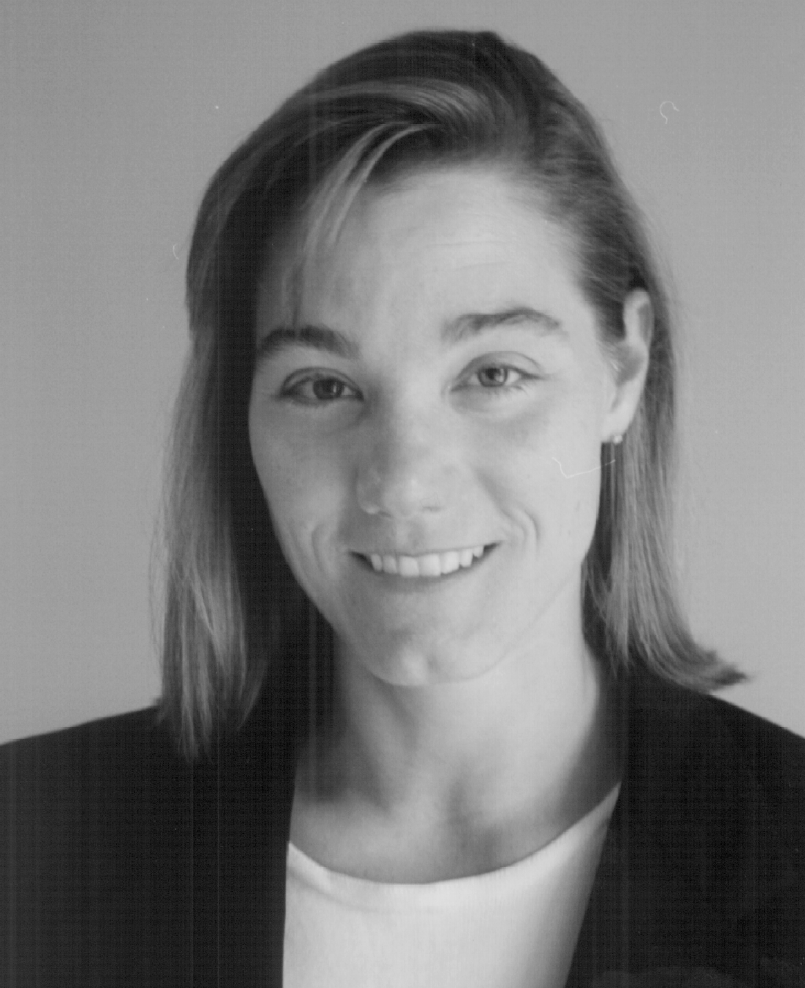

Education

2008 Certificate Number 1712
American Osteopathic Board of Orthopedic Surgery

2004-2005 The Philadelphia Hand Center
Thomas Jefferson University Hospital
Philadelphia, PA
Hand and Microvascular Surgery Fellowship

2000-2004 Philadelphia College of Osteopathic Medicine
Philadelphia, PA
Orthopedic Surgery Residency

1999-2000 Philadelphia College of Osteopathic Medicine
Philadelphia, PA
Transitional Internship

- 1999 University of Health Sciences College of Osteopathic Medicine
Kansas City, MO
Doctor of Osteopathic Medicine

  - University of Pennsylvania
Philadelphia, PA
Post Baccalaureate Program

1989-1991 Columbia University College of Physicians and Surgeons
New York, NY
M.S. Physical Therapy

1983-1987 St. Lawrence University
Canton, NY
B.S. Psychology, Sports Medicine

Employment & Experiences

2023 MES Solutions
505 South 336th St. #150
Federal Way, WA 98003
Independent Medical Examiner
Washington State Workers Compensation

2023 Briotix Health Solutions
9000 E Nichols Avenue. #104
Centennial, Colorado 80112
Senior Clinical Reviewer
Senior Clinician Quality Management Committee
Washington State Utilization Review

2023 Medilitix
7500 Brooktree Road STE 300
Wexford, PA 15090
Utilization review/peer reviewer
PA State Workers Compensation

2023 Hazleton Orthopedics & Therapy
236 W Broad St.
Hazleton, PA 18201
May 2023 – present

2023 Harrisburg Orthopedics & Therapy
2939 N 7th St
Harrisburg, PA 17110
June 2023 – present

2023 Olney Orthopedics & Therapy
199 W Nedro Ave
Philadelphia, PA 19120
June 2023 - present

2021 Riverside Regional Medical Center
Staff Orthopedic Surgeon
500 J Clyde Morris Blvd
Newport News, Virginia 23601
June 2021-June 2023

2021 American Osteopathic Board of Orthopedic Surgery
National Board, Senior Examiner
2010-present

2019 Lebanon VA Medical Center
Medical Staff Executive Board
Staff Representative
1700 South Lincoln Avenue
Lebanon, PA 17042
2019-2021

2015 Forward Surgical Team
United States Army
Helmand Province, Afghanistan
May-September 2015

2013 Lebanon VA Medical Center
Staff Orthopedic Surgeon
1700 South Lincoln Avenue
Lebanon, PA 17042
2013-2021

2012 Assistant Professor of Surgery
Uniformed Services University of The Health Sciences
April 2012-June 2018

2011 Walter Reed National Military Medical Center
Department of Orthopedic Surgery
Trauma Team- Upper Extremity Surgery
Bethesda, MD
September 2011- November 2013

2011 Forward Surgical Team
United States Army
Kunar Province, Afghanistan
January-September 2011

2010 University of Medicine & Dentistry of New Jersey
NeuroMusculoskeletal Institute
Assistant Professor & Orthopedic Surgeon
42 East Laurel Road, Suite 1700
Stratford, NJ 08084
2010-2012

2010 University of Medicine and Dentistry of New Jersey-School of Osteopathic Medicine
Orthopedic Surgery Residency
Assistant Program Director
2010-2012

2009 Forward Surgical Team
United States Army
Ghazni Province, Afghanistan
July-October 2009

2009 Delphi Healthcare Partners
170 Southport Dr
Morrisville, NC
866-885-5522
Dec 1, 2009-2012

2009 Camden Clark Memorial Hospital
800 Garfield Ave
Parkersburg, WV 26101
March 1, 2009-2012

2008 Staff Orthopedic Surgeon
Kaiser Permanente
Honolulu, HI
May-September 2008

2007 Staff Orthopedic Surgeon
Tripler Army Medical Center
Honolulu, HI
April 2007-July2007

2006 Staff Orthopedic Surgeon
The Aroostook Medical Center
Presque Isle, ME
April 2006-December 2006

2005-2006 Staff Orthopedic Surgeon
Eisenhower Army Medical Center
Ft. Gordon, GA
August 2005- March 2006

1987-2019 Lieutenant Colonel
United States Army Reserve Medical Corps
Airborne

1990 Executive Officer
279th Blood Bank Detachment in support of Desert Storm
KKMC, Saudi Arabia

1991-1999 Staff Physical Therapist
Albert Einstein Medical Center, Philadelphia, PA

1993-2000 Staff Physical Therapist
Hospital of the University of Pennsylvania, Philadelphia, PA

1995-1999 Staff Physical Therapist
St. Luke’s Hospital, Kansas City, MO

Research & Publications

2016 High Resolution Ultrasound in Combat-Related Peripheral Nerve Injuries.
Smith JK, Miller ME, Carroll CG, Faillace WJ, Nesti LJ, Cawley CM, Landau ME. Muscle Nerve.2016 Dec;54(6):1139-1144.doi:10.1002/mus.25216. Epub 2016 Oct 15. PMID:27299856.

2015 Translating Research into Practice: Is Evidence- Based Medicine Being Practiced in Military-Relevant Orthopedic Trauma?
Miles SE, Balasz GC, Cawley CM, Bosse M, MacKenzie E, Li Y, Andersen RC. Mil Med. 2015 April; 180(4):445-53. Doi:10.7205/MILMED-D-14-00296. PMID:25826350.

2014 High Resolution Ultrasound in Combat-Related Peripheral Nerve Injuries: A Case Series (P6.083). Neurology April 8,2014;82. Jonathan K. Smith MD, Matthew E. Miller MD, Craig G. Carroll DO, Walter J. Faillace MD, Leon J. Nesti MD, Christina M. Cawley DO, Mark Landau MD.

2007 Ruth Jackson Orthopaedic Society Guide for Women in Orthopaedic Surgery. Edited by Lisa K Cannada, MD and Mary I O’Connor, MD. Contributed Appendix A and B.

2002 Axonal Regeneration Using Transplants of Genetically Engineered Cells in SCI. Presented at the American Spinal Injury Association, May 2-6, 2002, Vancouver, BC. Won first place paper award. M. D. Antonaccci, MD, JM Nothias, B.S., T. Parks, MD, C. Cawley, DO, M. Murray, PhD.

2002 Transplants of Unmodified Human Bone Marrow Stromal Cells In A Collagen Matrix Support Brainstem-Spinal Axonal Regeneration Across Complete Spinal Cord Transections. Presented at the Cervical Spine Research Society, December 5-7, Miami Beach, FL. MD Antonacci, MD, JM Nothias, B.S., R Fritch, B.S., T. Parks, MD, C. Cawley, DO, M. Murray, PhD.

2002 Tibia Vara Due to Focal Fibrocartilaginous Displasia. Poster presentation, American Osteopathic Association of Orthopaedics, September 19-21, Orlando Fl. St. Christopher’s Hospital for Children, Philadelphia. PA. C. Cawley, DO, M. Herman, MD.

2001 Results of Conservative Treatment for Lateral Epicondylitis: Analysis of Failure. Poster presentation, American Osteopathic Association of Orthopaedics, October 4-7, Palm Desert, CA. The Graduate Hospital, Philadelphia, PA. C. Cawley, DO, M. Lazarus, MD.

2000 Ganglion Cyst in the Tibial Nerve Sheath Mimicking a Lumbar Disc Herniation. Case report and review. Poster presentation, American Osteopathic Association of Orthopaedics, September 21-23, Columbus, OH. Western Orthopedics & Sports Medicine, Grand Junction, CO. C. Cawley, DO, M. Larry Copeland, DO, M. Reeder, MD.

1999 A Unique Presentation of Calcium Pyrophosphate Deposition Disease in the Fibular Head. Case report and review. Poster presentation, American Osteopathic Association of Orthopaedics, September 16-18, Seattle, WA. Hospital for Joint Disease, NY, NY. C. Cawley, DO, S. Kenan, MD, P. Desai, MD.

1998 Analysis of Gait With and Without a Brace in Stroke Patients. Poster Presentation, American Osteopathic Association of Orthopaedics. Rancho Los Amigos Rehabilitation Hospital, Downey, CA. C. Cawley, DO, J. Perry, MD, JK Gronley, MPT.

1998 Tubulation and Twisting of the Anterior Cruciate Ligament Graft: Evaluation of Properties in Comparison to Standard Graft Preparation.
Philadelphia College of Osteopathic Medicine, B. Le, DO, V. Distefano, MD, H Hillstrom, PhD, C. Cawley, MPT

1990 Masters Thesis: Comparison of Hamstring/Quadriceps Ratio in Professional Hockey Players.
Columbia University College of Physicians and Surgeons, Howard Kiernan, MD, Bart Nissenson, MD and the New York Rangers.

Honors & Awards

Afghanistan Campaign Medal with Star
Combat Action Badge
Joint Service Commendation Medal
Global War on Terrorism Service Medal
NATO Medal
Army Commendation Medal
National Defense Service Medal (2nd Award)
Armed Forces Reserve Medal with 20-year Silver Device
Armed Forces Reserve Medal (4th Award)
Army Achievement Medal
Army Service Ribbon
Parachutist Badge
2003 Russell S Hibbs Basic Science Award, Scoliosis Research Society
1999 Chief Intern, Philadelphia College of Osteopathic Medicine

1998 Women’s Olympic Ice Hockey Pool Selectee
1994 MVP, US National Women’s Ice Hockey vs. Sweden
1993 MVP, US National Women’s Ice Hockey vs. Switzerland
1987 MVP, NCAA All Star Game, Ice Hockey
1987 Honors in Sports Medicine, St. Lawrence University
1987 Deans List, St. Lawrence University
1987 NCAA Academic All-American, Ice Hockey
1986 Deans List, St. Lawrence University
1986 NCAA Academic All-American, Ice Hockey
1983 NCAA Rookie of the Year, Ice Hockey

Extracurricular

1988-1997 US National Women's Ice Hockey Team
Player, Left Wing

1993-1995 Course Instructor
Musculoskeletal I, II and III
Masters Program in Physical Therapy
Temple University, Philadelphia PA

1992-1993 Harvesting Specialist
Bone and Tissue Bank
Hospital of the University of Pennsylvania, Philadelphia PA

Professional Memberships

International Association of Independent Medical Evaluators
American College of Occupational and Environmental Medicine

Ruth Jackson Orthopedic Society
Nominating Committee 2008-2009
Mentoring Committee 2005-2012

American Osteopathic Academy of Orthopedics
Female Orthopedic Group Committee Chairman 2010

American Academy of Orthopedic Surgeons
Association of Military Surgeons of United States
American Society for Surgery of The Hand

Locum Tenens

2008 Kaiser Permenente
Honolulu, HI
Hand surgery & general call
Level II Trauma
15 May- 31 August

2008 Frankford Torresdale Hospital
Philadelphia, PA 19114
Level II Trauma Coverage
14-16 March
10-12 October

2008 Virtua West Jersey Hospital Marlton
90 Brick Road
Marlton, NJ 08053
856-355-6027
Level III
18-22 September
3,23 October
22,23,27,28,30 November
24-26, 29-1 Dec

2007 Community Medical Health Center
Scranton, PA
Level II Trauma Coverage
15-25 October
22-27 December

2007 Gnaden Huetten Memorial hospital/Palmerton Hospital
Lehighton, PA
level III
14-16 December

2005 The aroostook Medical Center
Presque Isle, ME
level III
5-15 August

Lectures

14 April 2010
Scapholunate Advanced Collapse and Scaphoid Nonunion Advanced Collapse
Weekly Academic Conference
UMDNJ Orthopedic Surgery Residency

20April 2010
Basics of Hand Surgery Physical Examination and Diagnosis
2nd Year Medical Students UMDNJ-SOM
Musculoskeletal Medicine Module

21 April2010
Exercise Guidelines for Older Adults
Community Lecture Series

16 September 2010
What’s New in the Treatment of Shoulder Pain
Community Lecture Series

5 October 2010
What you call it and what we do-Hand Surgery and CPT codes collide
NJ Chapter, AMERICAN ASSOCIATION OF Professional CODERS (AAPC)

1November 2010
Surgery on the Battlefield
UMDNJ General Surgery Grand Rounds

8 April 2009
The Ulnar Nerve
Weekly Academic Conference
UMDNJ Orthopedic Surgery Residency

22 February 2010
Hand Surgery problems- When to consult orthopedic surgery
Internal Medicine Academic Conference
Cherry Hill Hospital

