**Curriculum Vitae:**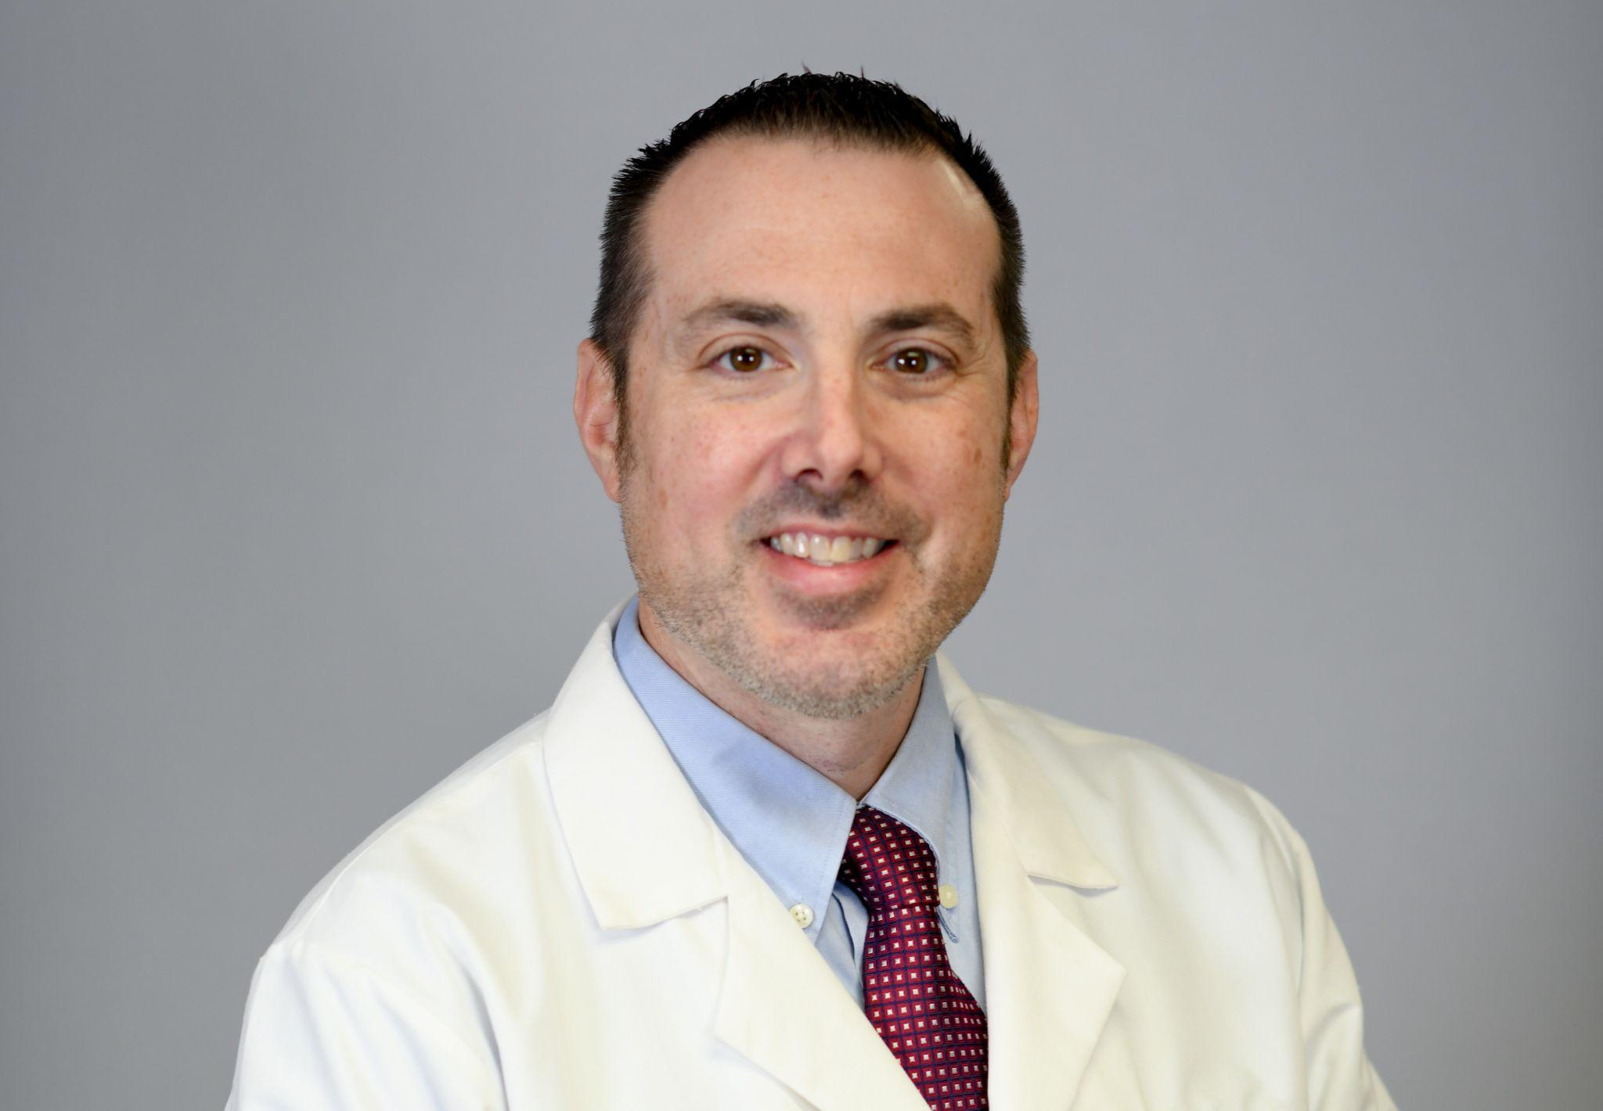

**Christopher W. Bader, DO**

**Cell: 732-216-4519**

**Fax: 732-405-2841**

**E-Mail: Badermedconsulting@gmail.com**

**Summary of Expertise:**

Dr. Bader is an award winning clinician and teacher. He has been Board Certified in Family Medicine and Osteopathic Manipulative Medicine (OMM) since 2009. Dr. Bader’s scope of practice has been focused on inpatient hospital (hospitalist) medicine since 2011. In addition to his work as a hospitalist he is also core faculty and director of inpatient medicine at a Family Medicine residency program. Dr. Bader is also director of osteopathic education for the residency program.

**Education:**

**Rutgers University-Robert Wood Johnson Medical School**

**Family Medicine Residency Program at CentraState**

**Medical Center, Freehold, NJ.**

*Family Medicine Resident/ Chief Resident*

Began post-graduate training in Family Medicine in

July 2006, with a graduation date of June 30, 2009.

Elected chief resident for the 2008-2009 academic year.

**Rowan University-School of Osteopathic Medicine, Stratford, New Jersey**

*Doctor of Osteopathic Medicine (D.O.)*

*May 2006*

**Saint Peter’s University, Jersey City, New Jersey**

*Bachelor of Science, Biology*

*Cum laude, May 2001*

**Honors:**

2023: Ocean University Medical Center Nurses’ Choice Physician of the Year

2022: Faculty of the year award, Ocean University Medical Center Family Medicine Residency

2018: Elected to Bayshore Medical Center’s Medical Executive Committee as an at-large member.

2017: Bayshore Medical Center Nurses’ Choice Physician of the Year

2016: Bayshore Community Hospital Nurses’ Choice Physician of the Year

2009: Society of Teachers of Family Medicine Resident Teacher Award

2002: Howard Levine Scholarship: Awarded by the NJ Association of Osteopathic Physicians and Surgeons.

**Academic Appointments:**

2018-present: Assistant Clinical Professor: Rowan University School of Osteopathic Medicine

2018- present: Clinical Professor: Hackensack Meridian School of Medicine

.

**Publications:**

Pangaro, Lt. Joseph and **Bader DO, Christopher**. *The Dangers, Health Risks, and*

*Consequences of Vaping.* Self Published. 2021.

[Lyme Carditis: A Rare Presentation of Sinus Bradycardia Without Any Conduction](https://pubmed.ncbi.nlm.nih.gov/31695976/)

[Defects.](https://pubmed.ncbi.nlm.nih.gov/31695976/) Grella BA, Patel M, Tadepalli S, **Bader CW**, Kronhaus K.

Cureus. 2019 Sep 2;11(9):e5554. doi: 10.7759/cureus.5554.

**Presentations:**

**Bader DO, Christopher**. *Connective Tissue Disorders.* Presented as a guest lecturer

at Monmouth University, West Long Branch, NJ, October 10, 2016

**Bader DO, Christopher** and Kirk DO, Michael. *Melding Art With Technology: The*

*Creation of a Universal Order Set.*  Presented at Care Guidance Conference,

New Orleans, LA, May 23-26, 2016.

**Professional Experience:**

June 2018

-present: **Ocean University Medical Center Family Medicine Residency Program, Brick, NJ**

*Core Faculty/Inpatient Medicine Director/Director of Osteopathic Education*

Serve as a core faculty member of the Family Medicine Residency and supervise the inpatient Family Medicine service. I also serve as the director of osteopathic education, which includes coordinating and delivering osteopathic-based lectures and running the program’s osteopathic manipulation clinic.

February 2015

-June 2018: **Physicians Practice Enhancement (PPE), Riverview Medical**

**Center, Red Bank, NJ, and Bayshore Medical Center,**

**Holmdel, NJ**

*Hospitalist Physician/ Medical Director*

Managed patients hospitalized at both acute care hospitals.

Served as medical director for the Bayshore Medical Center

hospitalist group. Duties included hiring and managing physician

personnel, making schedules, and serving on hospital

committees.

June 2014

-February 2015: **IPC, Riverview Medical Center, Red Bank, NJ and**

**Bayshore Medical Center, Holmdel, NJ**

*Hospitalist Physician*

Managed patients at both acute care hospitals. Also responsible

for responding to Code Blue and Rapid Response calls.

November 2011

-June 2014: **Apogee Physicians, Monmouth Medical Center Southern**

**Campus, Lakewood, NJ**

*Hospitalist Physician*

Managed patients in an acute care hospital.. Also responsible

for responding to Code Blue and Rapid Response calls.

July 2009

-June 2015: **House Physician, CentraState Medical Center, Freehold, NJ**

*Hospital Physician*

Responsible for all inpatients at CentraState Medical Center

overnight. Also responsible for admissions to the observation

unit during the overnight hours.

July 2010

-November 2011: **Family Practice of Central Jersey, Freehold/Colts Neck, NJ**

*Family Physician*

Physician in a group primary care practice. Cared for patient in

the outpatient, inpatient, and subacute rehabilitation settings.

November 2009

-November 2011 : **Family Medicine Center, Freehold, NJ**

*Family Physician/ Resident Preceptor*

Supervised and taught Family Medicine residents during their

clinical hours.

2009-2011 seasons,

2022 season:: **Sports Medicine New Jersey, Marlboro, NJ**

*Sideline Physician*

Cared for high school student athletes during the football season

and served as the sideline physician during games.

July, 2009

- July 2010: **Family Medicine, Manalapan, NJ**

*Family Physician*

Sole physician of a family medicine practice under the

employment of CentraState Medical Center. Cared for patients

in the outpatient, inpatient, subacute rehabilitation, and

home-based settings.

**Volunteer Experience:**

November 3, 2019

and November 6, 2022: **New York City Marathon, New York, NY**

*Medical Staff Physician*

Cared for competitors along the marathon course.

Volunteered along with family medicine residents at

Ocean University Medical Center.

October 2022-present: **Georgian Court University, Lakewood, NJ**

*Physician to Student Athletes*

Provide Osteopathic Manipulation to student athletes at

the university once monthly. Volunteer along with family

medicine residents at Ocean University Medical Center.

**Certifications:**

**National Board of Osteopathic Medical Examiners-** December 2007

**New Jersey State Board of Medical Examiners** - August 2008

**National Osteopathic Board of Family Physicians** - Board certified in Family Medicine and Osteopathic Manipulation, March 2009, recertified October 2018.

**American Heart Association Basic Life Support and Advanced Cardiovascular Life Support:** Most recent certification August 2022.

**Memberships:**

American Osteopathic Association

American College of Osteopathic Family Physicians

New Jersey Association of Family Physicians