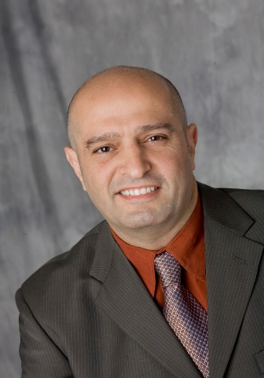
Curriculum Vitae
James J. Mahooti D.D.S.
FICOI , FMIII

General & Implant Dentist
731 Oceana Blvd.
Pacifica, CA 94044

Tel: 858-354-5400 (cell)
Email jamesmahooti@gmail.com

Professional Summary
Actively practicing dentist with 38 years of diverse clinical experience. 20+ years as a General Dentist and 18+ years as an Implant Dentist. Experience in high-volume and family practice settings. Northwestern University Trained/Educated. Over 3000 implants placed and/or restored.

Work History
General and Implant Dentist, June 2018 to Current
Shoreview Dental - Pacifica, California
- High-volume general and implant dentistry practice – approximately 400 patients/month
- Extensive full-mouth rehabilitation procedures
- Placed and restored approximately 30 implants/month

Additional Teaching Experience, January 2018 to July 2019
Hiossen Implant Company - San Diego, CA
- Designed curriculum and delivered lectures for aspiring entry-level implant dentists
- Taught pre-surgical 3D planning methods utilizing cone beam technology
- Instructed students how to perform sequential osteotomy and place implants on alveolar models

General and Implant Dentist, June 2015 to May 2018
Carlsbad Dental Care, Encinitas Dental Care - Carlsbad and Encinitas, California
- High-end dental practice serving mainly cash patients – approximately 175 patients/month
- Performed extractions, bone regeneration procedures and restorations
- Placed and restored approximately 30 implants/month

Curriculum Vitae- James Mahooti D.D.S. Page 2 of 3

Private Practice General and Implant Dentistry, September 1990 to August 2014
James Mahooti D.D.S. - San Diego, California
- Private General Dentistry Practice

General Dentist, April 1988 to July 1990
Personal Dental Service - El Cajon, California
- General Dentist in high-volume, multi-location clinic practice
- Performed extensive amounts of root canal procedures and extractions
- Managed over 20 patients/day

General Dentist, September 1986 to March 1988
Dr. Charles F. Labas Jr. - Waterbury, Connecticut
- General Dentist in Family Practice setting

Clinical Instructor, Dept. of Fixed Prosthodontics, July 1985 to August 1986
Northwestern University Dental School - Chicago, IL
- Supervised and instructed students to perform clinical procedures on patients
- Oversaw 6-8 students/semester

Education
Doctor of Dental Surgery: Dentistry, June 1985
Northwestern University Dental School - Chicago, IL
Undergraduate Biochemistry/Pre-Dental: Biochemistry, June 1981
Michigan State University - East Lansing, MI
- Completed undergraduate requirements in three years and transferred directly to Northwestern University Dental School

Current professional Affiliations
- American Dental Association
- California Dental Association
- San Mateo County Dental Society
- Fellow, International Congress of Oral Implantologists
- Fellow, Misch International Implant Institute

Curriculum Vitae-James J. Mahooti D.D.S. Page 3 of 3

Philanthropy
Mission trips to Tijuana through University of San Diego, 2009 to 2012
- Provided general dental services for underprivileged residents.

Mission trip to Honduras through UCLA School of Dentistry, 2011
- Taught techniques and supervised students in treatment of under privileged for basic dental needs.
Certifications
- Certified CEREC Trainer, Sirona 2008
- Created original protocol of CAD Smiles in cooperation with Certified Dental Technician. Fabricated and delivered CAD/CAM generated veneers and crowns in one appointment to the patients' full satisfaction.
Specialized training
Misch International Implant Institute 2006-2007
- Implant Dentistry including surgical and prosthetics disciplines
Dawson Academy of Higher Education
- Advanced courses in conventional and implant related full mouth rehabilitation with application of fundamentals of occlusion
University of Southern California School of Dentistry 2007
- Intravenous Conscious Sedation training under direction of Dr. Stanley Malamed
Advanced Endodontics, Dr. Stephen Buchanan, Santa Barbara late 1990's
- Courses included usage of microscopes for root canal procedures

