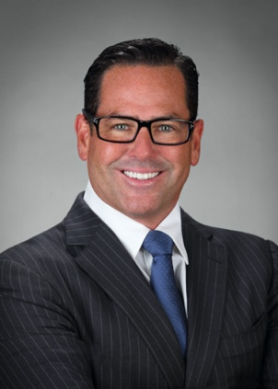

**Joseph J. Barrows, MD**

3501 Jamboree Road, Suite 1200

Newport Beach, California 92660

jbarrows@discmdgroup.com

310-993-4255 (cell)

**Board-Certified Anesthesiologist in active clinical practice. 15+ years experience. Over 4,000 spinal surgical procedures performed. Anesthesiologist for U.S. Olympic and Red Bull athletes, the Los Angeles Kings, and U.S. Navy SEALs. Extensive teaching experience. 10+ years experience as Medical Director of an Ambulatory Surgical Center (ASC). Experienced expert witness.**

**PROFESSIONAL MEDICAL EXPERIENCE**

**DISC Sports and Spine Surgery Center,** *Newport Beach, CA* **2011 to Present**

**Staff Anesthesiologist | Medical Director | Director of Anesthesia | Board of Directors**

* Provide and develop anesthetic plans for complex spinal and orthopedic surgeries.
* Organize anesthesia coverage for approximately 50 spine surgeries/month.
* Conduct peer reviews, design strategic policies and procedures.
* Provide leadership to team through lectures.
* Contribute to an effective decision-making process as a board of director and board member of the Medical Executive Committee (MEC).

**Partner, Deer Valley Anesthesia,** *Phoenix, AZ* **2008 to 2011**

* Developed and executed anesthetic plans for complex orthopedic and general surgeries.
* Prepared and presented monthly in-service lectures and executed peer reviews for group physicians.
* Orchestrated daily operating room anesthesia coverage schedules.

**Partner, The Anesthesia Medical Group, Inc.,** *Honolulu, HI* **2006 to 2008**

* Provided and developed anesthetic plans for complex spinal and orthopedic surgeries

**Director of Anesthesiology-** The Hayworth Institute, *Beverly Hills, CA* **2011 to 2015**

* Developed anesthetic plans for every type of cosmetic procedure.

**Anesthesia Technologist** at Cedars Sinai Medical Center, *Los Angeles, CA*  **2002**

* Assembled, instituted and tested all anesthesia-related devices including but not limited to the anesthesia machine, Intravenous lines, arterial line, and central lines, before every surgery.

**Medical Expert Witness 2020 to Present**

**Medical File Review Consultant 2020 to Present**

**EDUCATION**

**Anesthesia Residency**, Boston University Medical Center, *Boston, MA* **2003 to 2006**

**Surgical Internship**, St. Barnabas Medical Center, *Livingston, NJ* **2002 to 2003**

**Doctor of Medicine (MD)**, Saba University School of Medicine, **2002**

*Netherlands*

**Bachelor of Arts – Biology (BA)**, Kean University of New Jersey, *Union, NJ* **1995**

**Associates Degree**, Bergen Community College, *Paramus, NJ* **1991**

**LICENSES & CERTIFICATIONS**

Board Certified by The American Board of Anesthesiology, *10/2007*

Board Re-certification by The American Board of Anesthesiology, *6/2018*

State of California Medical license #A112561, *5/28/2010-present*

State of Hawaii Medical license #MD13848, *5/22/2006-present*

Medical Expert Witness Certificate, State of Florida, *6/9/2021*

**CURRENT PROFESSIONAL ASSOCIATIONS**

Member of the American Medical Association

Facility Member of the Ambulatory Surgical Center Association

**PERSONAL/OTHER**

First in family to go to college. Put myself through college by working in construction and bartending. Excellent verbal communication skills.