**John Richard Williams, PA-C**

Curriculum Vitae

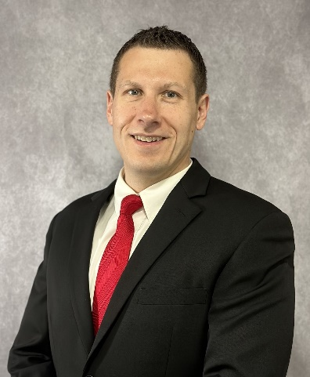

**ADDRESS/CONTACT**

Third Opinion MD, LLC Tel. 706-982-4156

P.O. Box 384

Clayton, GA 30525

[referrals@thirdopinionmd.com](mailto:referrals@thirdopinionmd.com)

**EDUCATION AND POSTGRADUATE TRAINING**

Bachelor of Science in Biology, Minors in Chemistry and Spanish, North Georgia College & State University 2008

Master of Public Administration with Healthcare concentration, North Georgia College & State University 2010

Master of Physician Assistant Studies, Lincoln Memorial University 2014

**LICENSURE AND CERTIFICATIONS**

Georgia Composite Medical Board 2014-present

North Carolina Medical Board 2023-present

South Carolina Medical Board 2022-present

National Commission on Certification of Physicians Assistants 2014-present

Basic Life Support (BLS) 2021-present

Advanced Cardiovascular Life Support (ACLS) 2021-present

Pediatric Advanced Life Support (PALS) 2021-present

Advanced Trauma Life Support (ATLS) 2014-2022

**MEDICAL LEGAL EXPERIENCE**

Expert Witness/Consulting 2022-present

Trial and Deposition Experience

Plaintiff and Defense Work

**MEDICAL PROFESSIONAL EXPERIENCE**

Third Opinion MD, 2022-present

Life Point Medical, Internal Medicine Physician Assistant 2020-2022, 2024-present

St. Mary’s Sacred Heart Hospital, Emergency Medicine Physician Assistant 2014-present

Angel Medical Center, Emergency Medicine Physician Assistant 2022-2023

The Longstreet Clinic, Orthopedic Physician Assistant 2019

Habersham Medical Center, Emergency Medicine Physician Assistant 2015-2019

TeamHealth-Piedmont Mountainside and Hamilton Hospital, Emergency Medicine Physician Assistant 2015

Northeast Georgia Medical Center, OR Inventory Control Tech 2010-2012

**DISCIPLINARY ACTIONS, SANCTIONS, LAWSUITS**

None

**PROFESSIONAL AND HONOR SOCIETY MEMBERSHIPS**

American Academy of Physicians Assistants (AAPA) 2012-2021

Georgia Association of Physician Assistants (GAPA) Student member-2014, former member 2018

**HONORS AND AWARDS**

Beta Beta Beta Biological Honor Society 2008

Study Abroad-London, England (2006), Athens, Greece (2007) and Nerja/Santander, Spain (2008)

**COMMUNITY VOLUNTEER, MILITARY AND CIVIC ACTIVITIES**

Involved with Children’s Ministry at Clayton Baptist Church, Clayton, GA. 2020-present

Good News Clinic- Medical Assistant volunteer 2010-2012

Medical Mission and Mission Trips-Germany (2006), Mexico (2003,2008), Haiti (2014)

**PERSONAL INTERESTS**

Emergency Medicine, Internal Medicine, Orthopedics

Community Health and Prevention

Family, Running, Fitness/exercise, Fishing, Mountain Biking, Camping, Traveling, Archeology/History

Revised 1/2/25