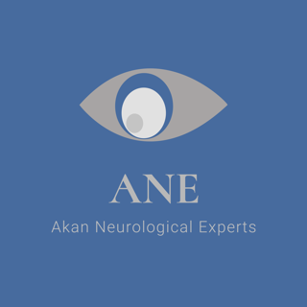

**Dr. E. Andy Akan, M.D.**

**642 Shannon Bridge, Dyer, Indiana 46311**

**(773)742-3974**

**eakan14@gmail.com**

***Curriculum Vitae for Dr. E. Andy Akan, M.D***

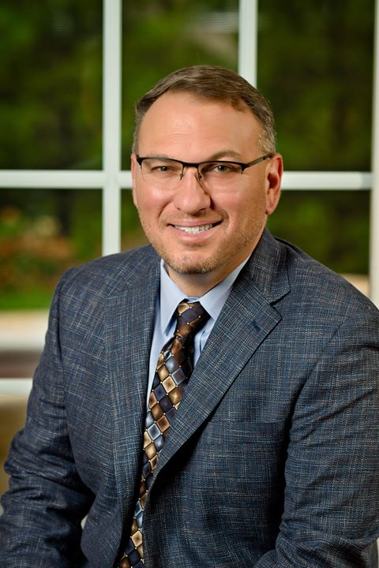

**SUMMARY OF EXPERTISE**

**Fourteen years of experience in hospital and outpatient neurology. Three years of experience as the admitting physician in an acute rehabilitation unit. Five years of experience caring for patients in a skilled nursing and assisted living facility. Medical director of one of three comprehensive stroke programs in the state of Indiana. Medical director of quality in a free-standing stroke and rehabilitation hospital. Ten years of experience serving on the Department of Medicine Quality subcommittee. Professor and physician mentor at the Indiana University School of Medicine. Ten years of experience as a pharmaceutical speaker bureau physician presenter.**

**Areas of expertise include:**

* **Traumatic Brain Injury**
* **Post-concussive syndrome**
* **Spinal Injury and Pathology**
* **Epilepsy**
* **Stroke and Tissue Plasminogen Activator Administration**
* **Intracranial Hemorrhage**
* **Multiple Sclerosis and other demyelinating diseases**
* **Post stroke and injury rehabilitation**
* **Parkinson’s Disease and other movement disorders**
* **Disorders of the visual system**
* **Migraine and other headache syndromes**
* **Idiopathic and toxin associated neuropathies**
* **Myopathies and other muscular disorders**
* **Myasthenia gravis and other neuromuscular diseases**
* **Primary and secondary tumors of the nervous system**
* **Disorders of the vestibular system**
* **Neurophysiology including EEG and EMG studies**

**PROFESSIONAL EXPERIENCE**

# **Community Care Network NWI Neurological Associates, Munster, IN**

# **June 2017 - Current**

* **Medical Director Comprehensive Stroke Program, Munster Community Hospital**
* **Director of Quality, Community Stroke and Rehabilitation Center**
* **Medical Executive Committee Board Member, Community Stroke and Rehabilitation Center**
* **Quality Committee member, Department of Medicine, Munster Community Hospital**
* **Quality Committee member, Department of Neurosciences, Munster Community Hospital**
* **Physician Champion, Organ Donation Committee, Munster Community Hospital**

**Northwest Indiana Neurological Associates, Munster, IN,**

August, 2005 – May, 2017

* **Partner**

**Pharmaceutical Bureau Physician Speaker; Novartis, Pernix, and Allergan**

# 

# **University of Illinois at Chicago Medical Center,** Chicago, IL

# July 1, 2002 - June 30, 2005***,* Neurology Residency,**

* **Chief Resident*, 2004-2005***

**Lutheran General Hospital**, Park Ridge, IL

July 1, 1999- June 30, 2002, **Categorical Internal Medicine Residency**

* **Spirit Award recipient for excellence in leadership and patient care**

**EDUCATION**

**University of Illinois at Chicago**

***Doctor of Medicine,*** May 1999

* **Clinical Honors received in General Surgery, Radiology, Neurology, Orthopedic Surgery, Psychiatry, Otolaryngology, and Family Practice**
* **Medical School Class President**

**University of Illinois**,Urbana-Champaign, IL

***B.S. Biology,*** December 1994

* **Dean’s List, 6 semesters**
* **Illinois General Assembly Scholarship**
* **Alpha Epsilon Delta Premedical Honor Society**

**BOARD CERTIFICATION AND LICENSE**

* **State of Indiana Physician License #01060698A**
* **Diplomat, American Board of Psychiatry and Neurology**

**ACADEMIC APPOINTMENTS**

* **Adjunct Assistant Clinical Professor, Indiana University School of Medicine, Department of Neurology**

**PROFESSIONAL ORGANIZATIONS**

* **American Academy of Neurology**
* **American Medical Association**

**COURTROOM TESTIMONY**

* **Experience in deposition and trial testimony**

**RESEARCH**

* **Department of Energy Research Semester and Summer**

**Argonne National Laboratory; Argonne, Illinois**

**Research Assistant** ▪ Summer 1993, January 1995- August 1995

* **Department of Biochemistry, University of Illinois at Urbana**

**Laboratory technician** ▪ June 1994 – December 1999

**PUBLICATIONS**

**Akan E**, Chang-Liu C, Watanabe J, Ishizawa K, Woloschak G; *The effects of Vinblastine on the expression of human immunodeficiency virus type 1 long terminal repeat.* Leukemia Research; 21, No 5; 459-464; January 1997.

Panozzo J, **Akan E**, Griffiths D, Woloschak G; *The effects of 5-Fluorouracil and Doxorubicin on expression of human immunodeficiency virus type 1 long terminal repeat.* Cancer Letters; 105(2); 217-223; August 1996.

Panozzo J, Panozzo Ja, **Akan E**, Libertin C, Woloschak G; *The effects of Cisplatin and Methotrexate on the expression of human immunodeficiency virus type 1 long terminal re* Ambulatory Care Conference; Topic: Outpatient Management of Headache;

**LECTURES AND SEMINARS**

# **Speaker, Alzheimer’s Association of Northern Indiana**

* **Speaker, Munster Community Hospital Stroke Fair**
* **Speaker, Heart and Brain Symposium, Munster Community Hospital**
* **Speaker, Donate Life Rose Ceremony**
* **Presenter, Neuroscience Seminar; Topic: Cerebral Cortex; Cytoarchitecture and Function; University of Illinois Medical Center**