Experience
  - 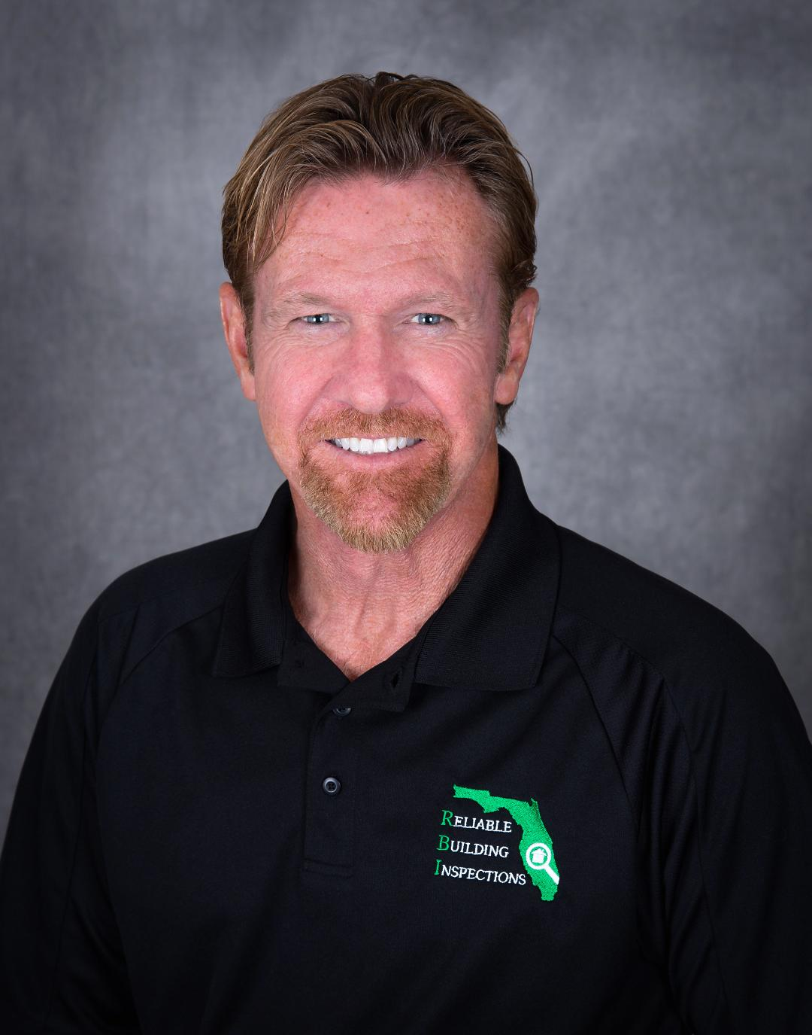

steve rohal
  - Owner & President

Skills & Abilities
Associate Certified Entomologist ACE University of Florida Dept. of Entomology
Alabama Certified Operator-Wood Destroying Organisms- permit number 2005089
Florida Certified Pest Control Operator including Fumigation and Wood Destroying Organism Inspector CF5270
Licensed Home Inspector-FL.
Entomological Society of America Member ID: 70864
Certified Residential Thermographer (infrared) CRT
Florida Mold Assessor - license number MRSA2893
Council-certified Microbial Consultant ACAC Certificate Number 1805026
T 407-837-3892 -direct

Reliable Pest & Termite Services, Inc.
  - 9/2005-Current d/b/a RELIABLE BUILDING Inspections
  - Owner/PRESIDENT – Forensic commercial and residential building inspection for defects including mold growth, deficient termite treatment and structural termite damage, Licensed Fumigator, wood destroying organism expert, WDO inspection trainer, Staff Entomologist.

  - Envirotect Pest Services
  - 8/1992-9/2005 Owner/President- Forensic commercial and residential building inspection for defects including mold growth and termite damage, licensed fumigator, wood destroying organism (WDO) inspection trainer, Provided termite treatments including bait systems. Company sold.
MASSEY SERVICES -General Manager 1990-1992 Duties included interface with state regulators, termite damage claims.
ORKIN PEST CONTROL- Termite sales, Sales Manager, Branch Manager 1980-1990 Omaha, Nebraska & Florida -Lake Mary Branch. Duties included interface with state regulators, termite damage claims.
UNITED STATES AIR FORCE
1976-1980 Offutt AFB, Nebraska
Member of Base Engineer Emergency Force (Prime BEEF) Rapidly Deployable Civil Engineer Unit

Education

University of Florida -Entomology Studies ACE Program

ENTOMOLOGICAL SOCIETY of AMERICA- ESA

FLORIDA ASSOCIATION OF BUILDING INSPECTORS- Instructor for peer review. Master Professional Inspector #401
SEAK, INC. -Testimony, Deposition, and Expert Witness training
INTERNATIONAL CODE COUNCIL MEMBER ICC
PRO LAB - MOLD IDENTIFICATION and SAMPLING
AMERICAN SOCIETY of HOME INSPECTORS – ASHI
CERTIFIED PEST CONTROL OPERATORS of FLORIDA- annual CEU training and membership
Orkin Pest Control Branch Manager Training Program -Atlanta, Ga. – graduated at top of class with the President’s Award for Excellence
University of Nebraska at Omaha -1977-1978
Community College of The Air Force -1976 Civil Engineering
Miami Dade Community College -1974-1975

PUBLISHED WORK
Author of the book published in 2000- Winning the War on Pests! -Tips and Tactics from The Pros
Power Point presentation – ‘Who, What, When, Why : Florida 13645 WDO Inspections’

LEADERSHIP
Florida Association of Building Inspectors -peer review instructor
Orkin Management -Presidents Club for Excellence

